Name

Mathematics Stage 5 Path
Simultaneous Equations

Book 1 | Solve linear simultaneous equations, both algebraically and graphically | Version: 260720  Feedback:  https://MrDingMaths.com
Contents
Syllabus Content 2
Identifying the Simultaneous Solution 3
Solving Simultaneous Equations Graphically 8
Solving by Substitution 17
Solving by Elimination (No Adjustment) 25
Solving by Elimination (Adjustment Required) 31
Applications of Simultaneous Equations 37
Identities and Contradictions 51
Proving Identities 54
Equating Coefficients 57
Splitting the Numerator 63

Syllabus Content
MA5-EQU-P-02 solves linear equations of more than 3 steps, monic and non-monic quadratic equations, and linear simultaneous equations
Solve linear simultaneous equations, both algebraically and graphically
- Solve linear simultaneous equations by finding the point of intersection of their graphs
- Solve linear simultaneous equations using algebraic techniques including substitution and elimination methods
- Model and solve word problems using simultaneous equations and interpret their solutions
- Describe an identity as an equation that is true for all values of the pronumeral and relate the identity to coincident lines
- Describe a contradiction as an equation that has no solutions and relate the contradiction to parallel lines

Identifying the Simultaneous Solution

- Investigation Simultaneous solution
- Consider $y=x+1$.
What values of $x$ and $y$ satisfy this equation?
$$x$$
$$y$$

- Consider $y=-x+5$.
What values of $x$ and $y$ satisfy this equation?
$$x$$
$$y$$

- What are the values of $x$ and $y$ that will satisfy both equations at the same time?

If we graph both linear equations on the same axis,
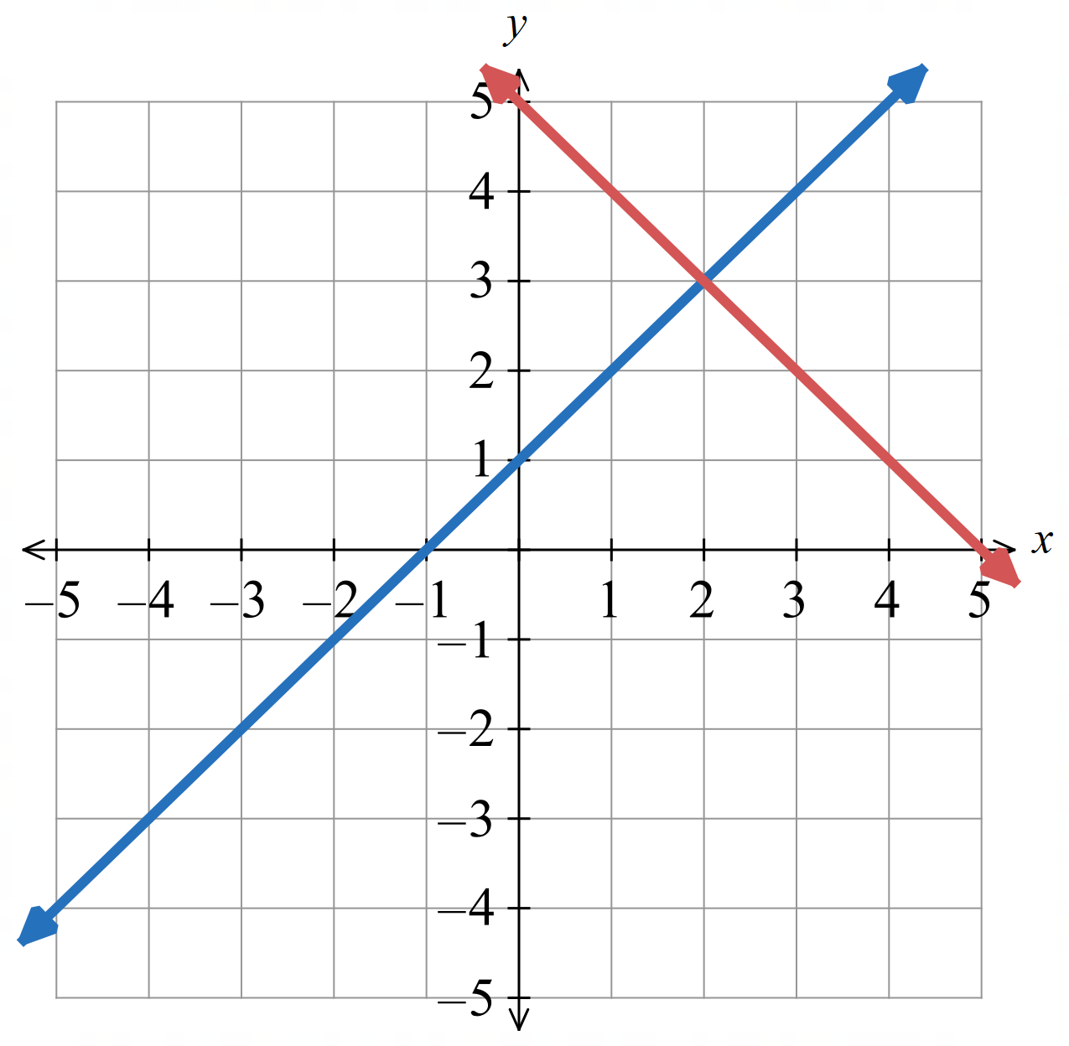
the coordinates of the point of intersection
satisfy both equations at the same time.
$x=2$, $y=3$

- Identifying the Simultaneous Solution
Solving equations simultaneously means finding the $x$ and $y$ values that make two equations true at the same time.
The $x$ and $y$ coordinates where the two lines meet solves both equations.
To find the simultaneous solution:
- Identify point of intersection.
- State the $x$ and $y$ values at the point of intersection.

- Identify simultaneous solution
- Find the values of $x$ and $y$ that solve $y=6-3x$ and $y=2x+1$ simultaneously  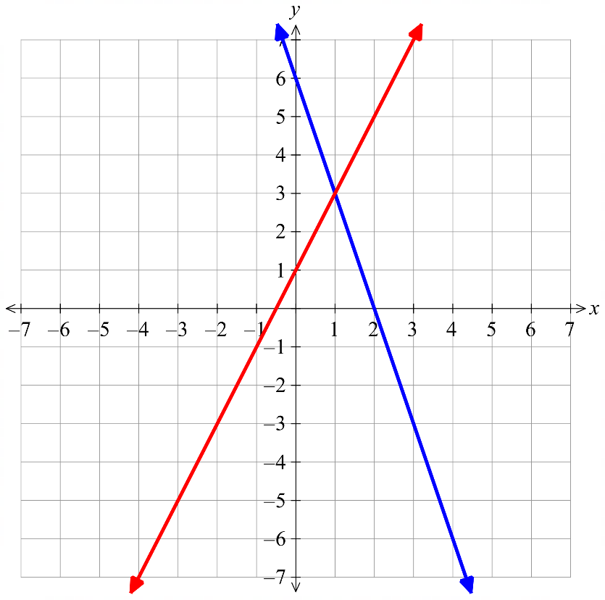  $$\left(1,3\right)$$  $$y=6-3x$$  $$y=2x+1$$  The point of intersection is: …………  The solution to both equations is:  $x=$ ………… $y=$ ……… | 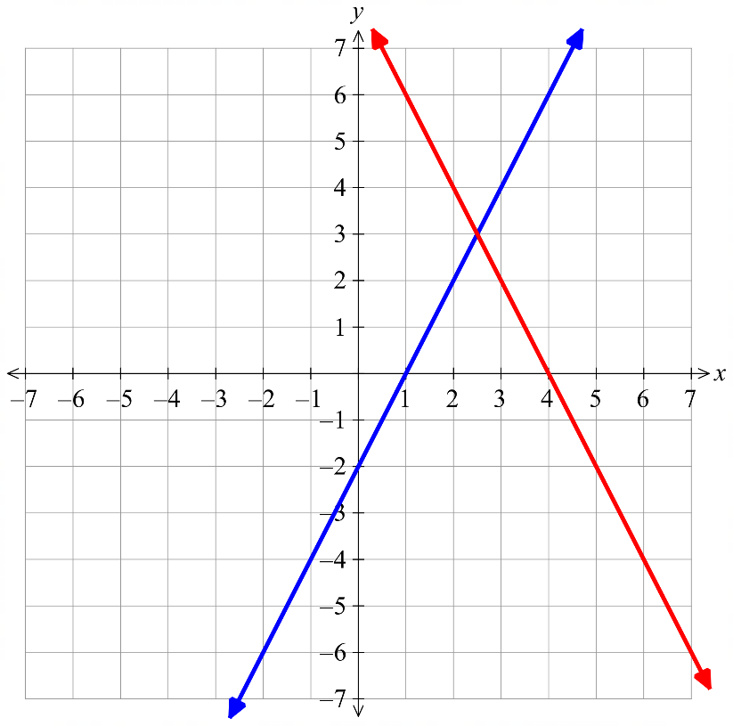  - Find the values of $x$ and $y$ that solve  $y=2x-2$ and $y=8-2x$ simultaneously  $$y=2x-2$$  $$y=8-2x$$  The point of intersection is: …………  The solution to both equations is:  $x=$ ………… $y=$ ………

- Key Ideas
- To solve two equations simultaneously means to find the values of $x$ and $y$ that make both equations …………… at the same time.
- Every point on a line is a ………………… to the equation.
- The point of ……………… of two lines solves both equations, as it lies on ……… the lines

Foundation
- Determine the point of intersection and hence solve these equations simultaneously.
The point of intersection is: …………………  The solution to both equations is:  $x=$ …… $y=$ ……  $$x=-1, y=2$$ | 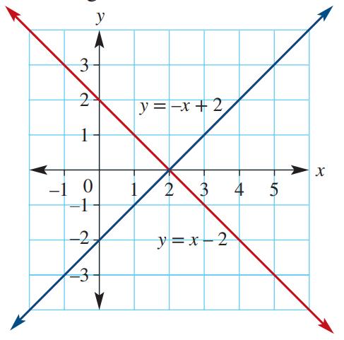  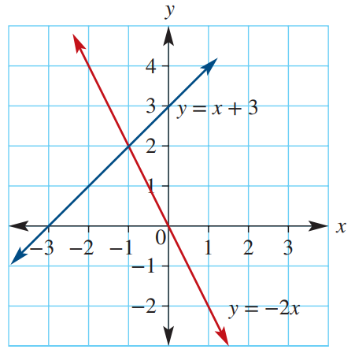  The point of intersection is: …………………  The solution to both equations is:  $$x=2, y=0$$
The point of intersection is: …………………  The solution to both equations is:  $$x=4,y=3$$ | 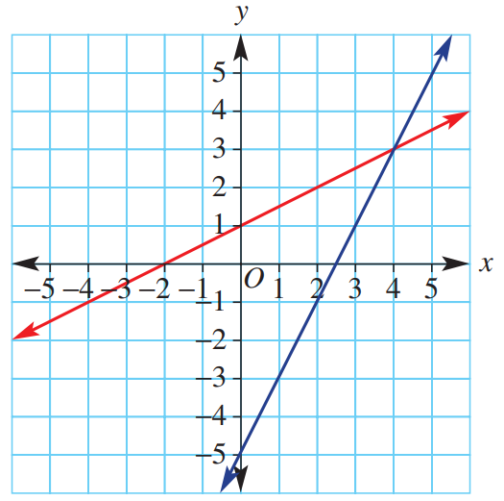  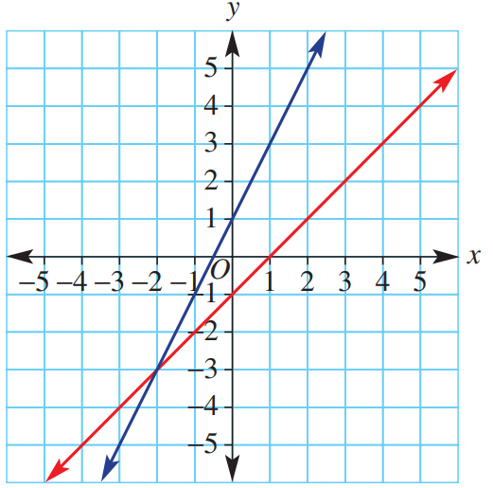  The point of intersection is: …………………  The solution to both equations is:  $$x=-2, y=-3$$
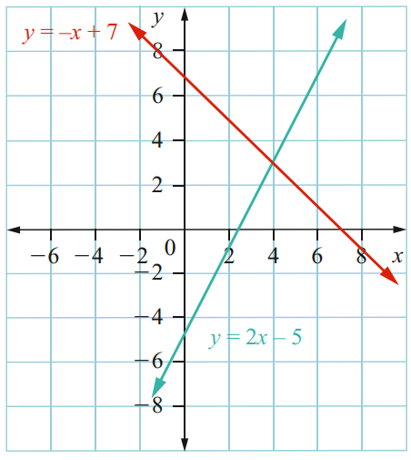  The point of intersection is: …………………  The solution to both equations is:  $$x=4, y=3$$ | 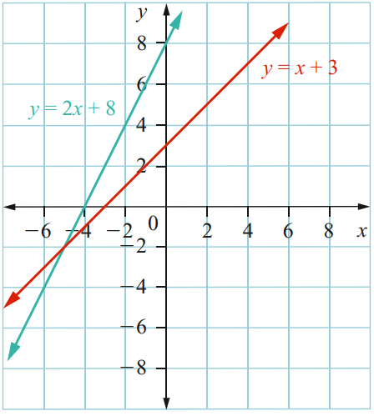  The point of intersection is: …………………  The solution to both equations is:  $$x=-5, y=-2$$

Development
- Verify that the point of intersection solves both equations simultaneously.
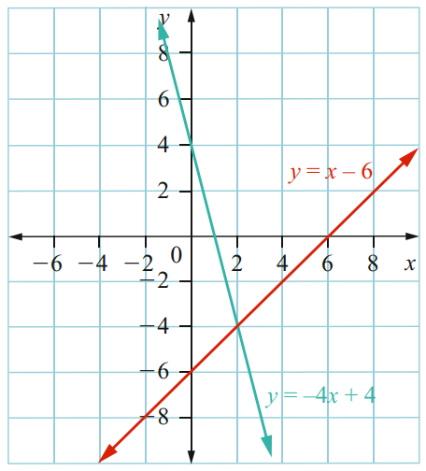  Point of intersection is: ………………  $$(2,-4)$$  Verify: | 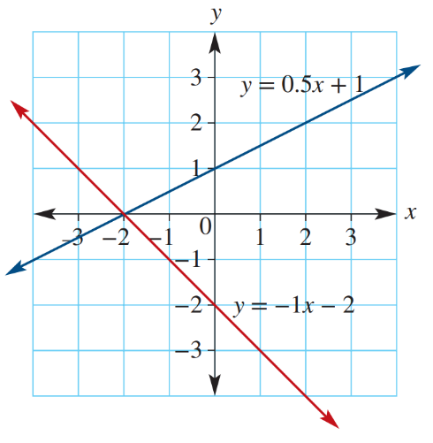  Point of intersection is: ………………  $$\left(-2,0\right)$$  Verify:
  $$y=x-6$$ | $$y=-4x+4$$
  $$y=0.5x+1$$ | $$y=-x-2$$

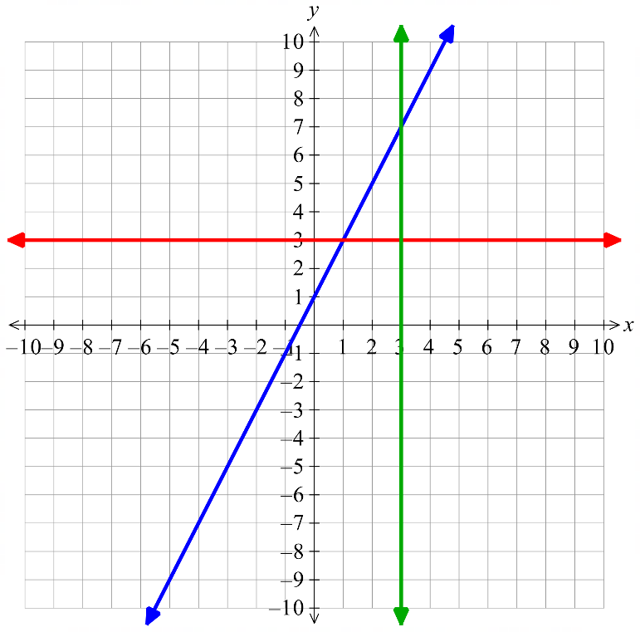
- Here are the graphs of
$y=2x+1$
$x=3$
$y=3$
$$y=2x+1$$
$$y=3$$

$$x=3$$

- Identify the coordinates of the point of intersection of $y=2x+1$ and $x=3$  $$\left(3, 7\right)$$ | - Substitute $x=3$ into the equation  $y=2x+1$ and evaluate $y$.  $$y=7$$
- Identify the coordinates of the point of intersection of $y=2x+1$ and $y=3$  $$\left(1,3\right)$$ | - Substitute $y=3$ into the equation  $y=2x+1$ and solve for $x$.  $$x=1$$

Mastery
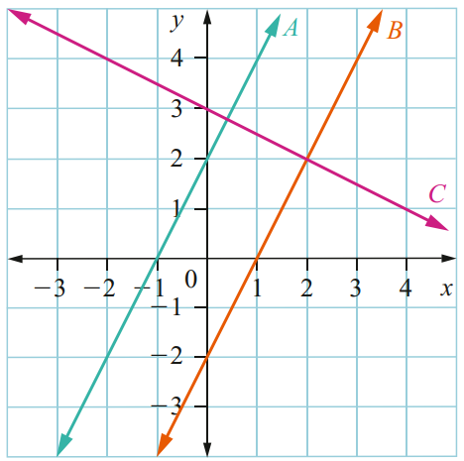
- Consider the straight lines A, B and C shown on this graph.
  - Write the coordinates of the point of intersection of lines B and C and hence give the solution to the simultaneous equations for these lines.

$$\left(2,2\right)$$
  - Use the graph to solve the equations for lines A and C simultaneously (give an estimate).

$$≈\left(0.4, 2.8\right)$$
  - Can the equations for lines A and B be solved simultaneously? Explain why or why not.

No, they are parallel so will never meet. There’s no pair of $x$ and $y$ values that will solve both equations.
- When two different lines have the same gradient, there will be no intersection point.
Use this idea to decide if these pairs of simultaneous equations will have a solution.
- $y=3x-1$  $y=3x+1$  No solution | - $y=7x+2$  $y=7x+6$  No solution | - $y=2x-6$  $y=-2x+1$  Solution possible
- $y=-x+7$  $y=2x-1$  Solution possible | - $2x-y=4$  $y=2x+1$  No solution | - $7x-y=1$  $y=-7x+2$  Solution possible
- $2y-3x=0$  $$y=-\frac{3x}{2}-1$$  Solution possible | - $y=$ $\frac{x}{2}$ $+3$  $$\frac{x-2y}{4}=0$$  No solution

- For what value of $k$ will these pairs of simultaneous equations have no solution?
- $y=-4x-7$  $y=kx+2$  $$k=-4$$ | - $y=kx+4$  $3x-2y=5$  $$k=\frac{3}{2}$$ | - $kx-3y=k$  $y=4x+1$  $$k=12$$

Solving Simultaneous Equations Graphically

- Solving Simultaneous Equations Graphically
To solve two equations simultaneously:
- Construct table of values from each equation.
- Graph each line from the table of values.
- Identify point of intersection.

- Your graphs must be accurate. You cannot do a rough sketch.

- Example Solve simultaneous equations graphically
Solve these equations simultaneously: $y=2x+1$ and $y=4-x$
1. $y=2x+1$ | $y=4-x$
  $$x$$ | 0 | $$1$$ | 2 | 3
  $$y$$ | 1 | 3 | 5 | 7
  $$x$$ | 0 | $$1$$ | 2 | 3
  $$y$$ | 4 | 3 | 2 | 1
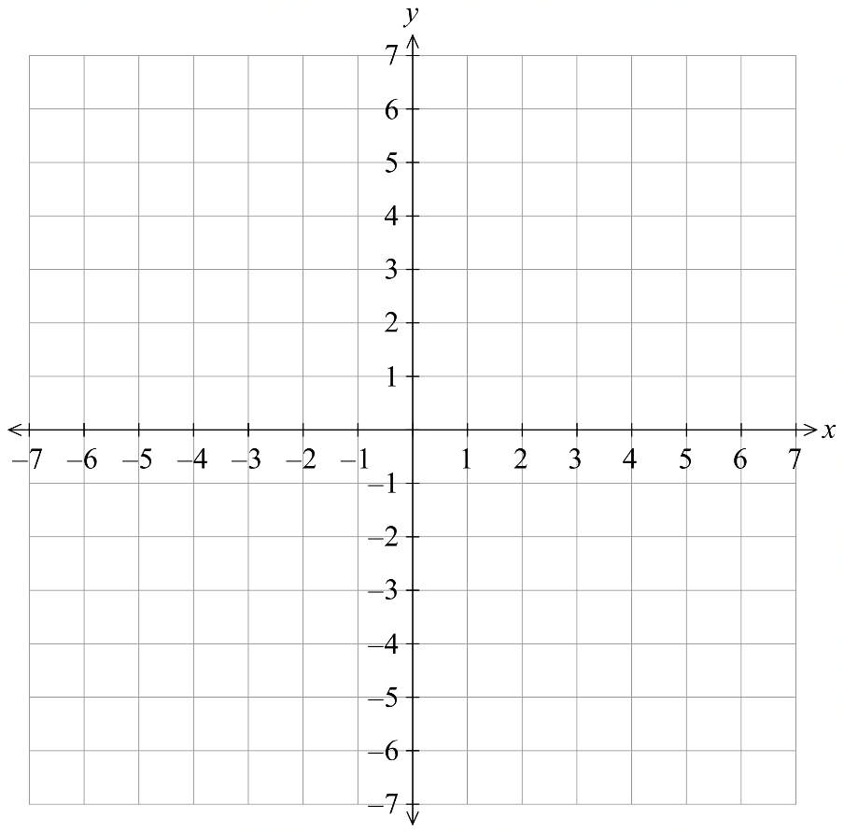  2. | 3.  The point of intersection is: $(1,3)$  The solution to both equations is:  $x=1, y=3$

- Guided Practice
Solve these equations simultaneously: $y=x+2$ and $y=2x-1$
1. $y=x+2$ | $y=2x-1$
  $$x$$ | 0 | $$1$$ | 2 | 3
  $$y$$
  $$x$$ | 0 | $$1$$ | 2 | 3
  $$y$$
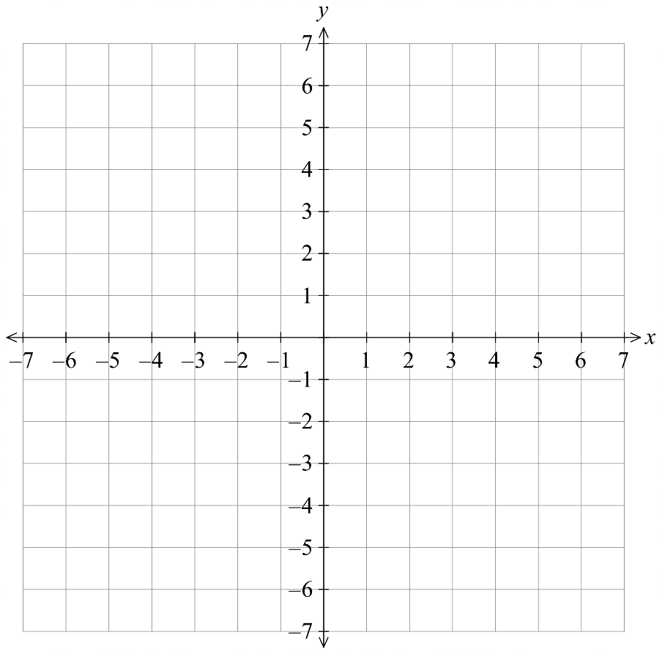  2. | 3.  The point of intersection is: …………  The solution to both equations is:  ………………………  $$x=3, y=5$$
Solve these equations simultaneously: $y=1-2x$ and $y=$ $\frac{x}{2}$ $+6$
1. $y=1-2x$ | $y=$ $\frac{x}{2}$ $+6$
  $$x$$ | 0 | $$1$$ | 2 | 3
  $$y$$
  $$x$$ | 0 | $$1$$ | 2 | 3
  $$y$$
2. | 3.  The point of intersection is: …………  The solution to both equations is:  ………………………  $$x=-2,y=5$$

- Key Ideas
- Every point on a line is a ………………… to the equation.
- The point of ……………… of two lines is the simultaneous solution, as it lies on ……… the lines

Foundation
- Plot the points on the Cartesian Plane and join them to form two straight lines.
What is the point of intersection?
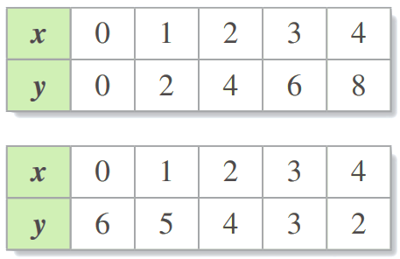
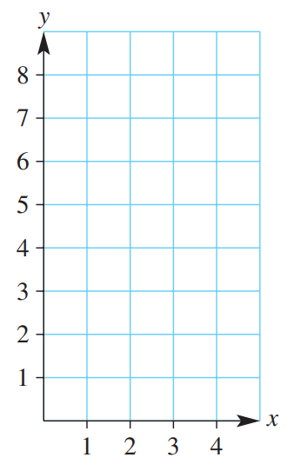

Point of intersection: ……………………
$$\left(2,4\right)$$

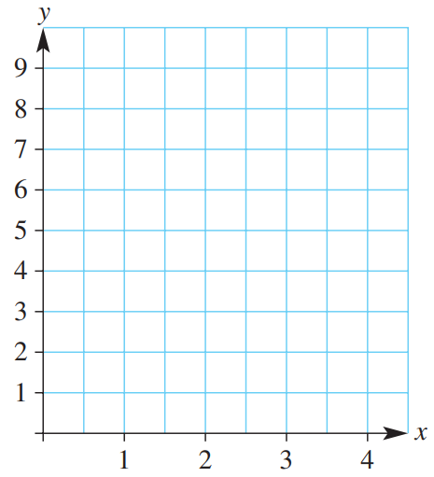
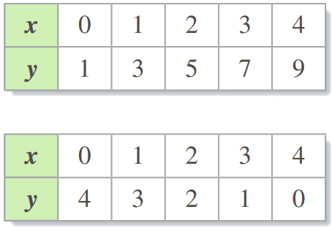

Point of intersection: ……………………
$$\left(1,3\right)$$

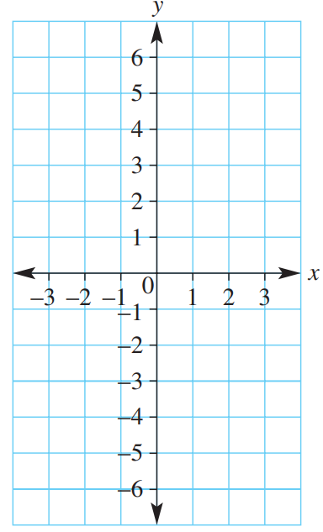
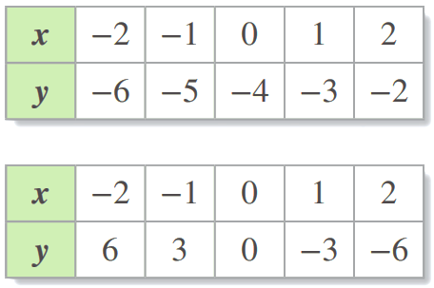

Point of intersection: ……………………
$$\left(1,-3\right)$$

- Looking at your answers to Q1, does the point of intersection appear on both tables of values?
yes
- Complete the following table of values and plot the points on a number plane.
What is the solution to each pair of simultaneous equations?
- $y = 2x-1$  $y=x+1$  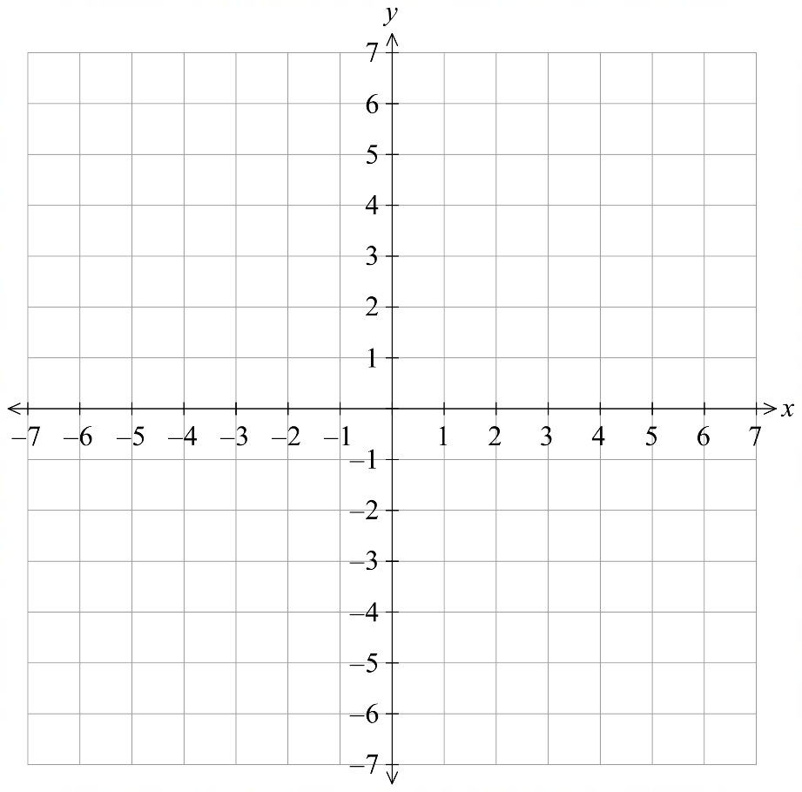  $$\left(2,3\right)$$ | - $y = -x$  $y=x+2$  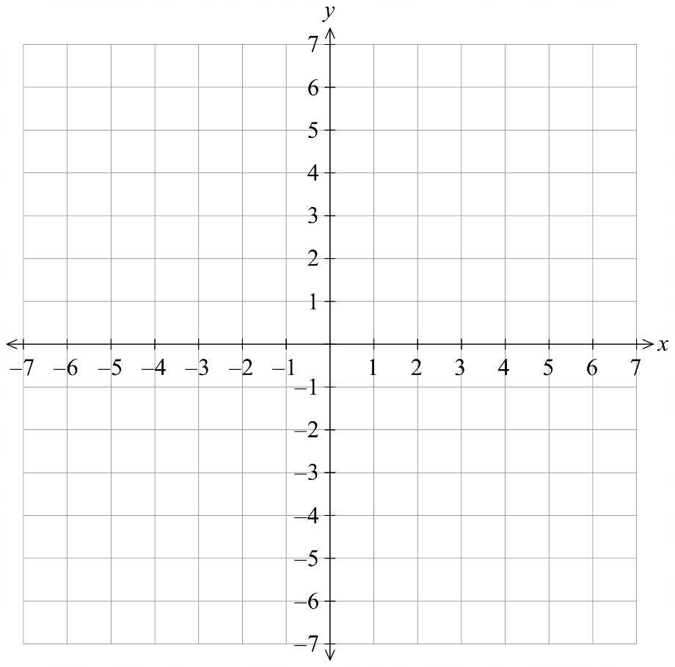  $$\left(-1,1\right)$$
  $$x$$ | $$-1$$ | 0 | $$1$$
  $$y$$
  $$x$$ | $$-1$$ | 0 | $$1$$
  $$y$$
  $$x$$ | $$-1$$ | 0 | $$1$$
  $$y$$
  $$x$$ | $$-1$$ | 0 | $$1$$
  $$y$$
- $y = 3x +1$  $y=5x-3$  $$\left(2,7\right)$$ | - $y = 3x - 3$  $y=x+1$  $$\left(2,3\right)$$
  $$x$$ | $$-1$$ | 0 | $$1$$
  $$y$$
  $$x$$ | $$-1$$ | 0 | $$1$$
  $$y$$
  $$x$$ | $$-1$$ | 0 | $$1$$
  $$y$$
  $$x$$ | $$-1$$ | 0 | $$1$$
  $$y$$

Development
- Consider the tables given below to find the $x$-value and the $y$-value that is the solution to each pair of simultaneous linear equations.
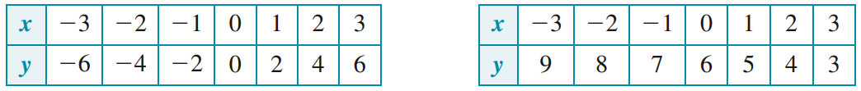
- $y=2x$ $y=6-x$

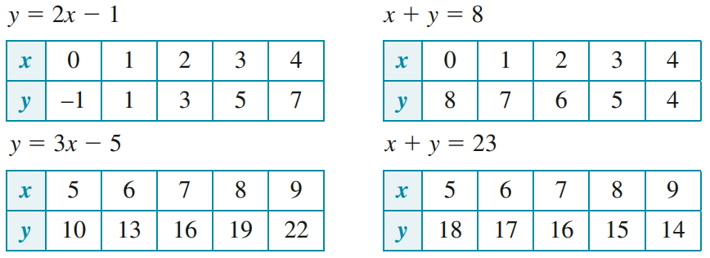
$x=$ ……… $y=$ ………
$$\left(2,4\right)$$
- $y=2x-1$ | $y=8-x$  $$\left(3,5\right)$$
- $y=3x-5$ | $y=23-x$  $$\left(7,16\right)$$
- Graph these on DESMOS to solve these pairs of simultaneous equations.
- https://www.desmos.com/calculator
  - $x+y=5$ and $2x+y=6$ ………………………
$$\left(1,4\right)$$
  - $3y+x=9$ and $2x-y=4$ ………………………
$$\left(3,2\right)$$
  - $x+y=-4$ and $x-y=2$ ………………………
$$\left(-1,-3\right)$$
  - $y=x^{2}+3$ and $y=2x+2$ ………………………
$$\left(1,4\right)$$
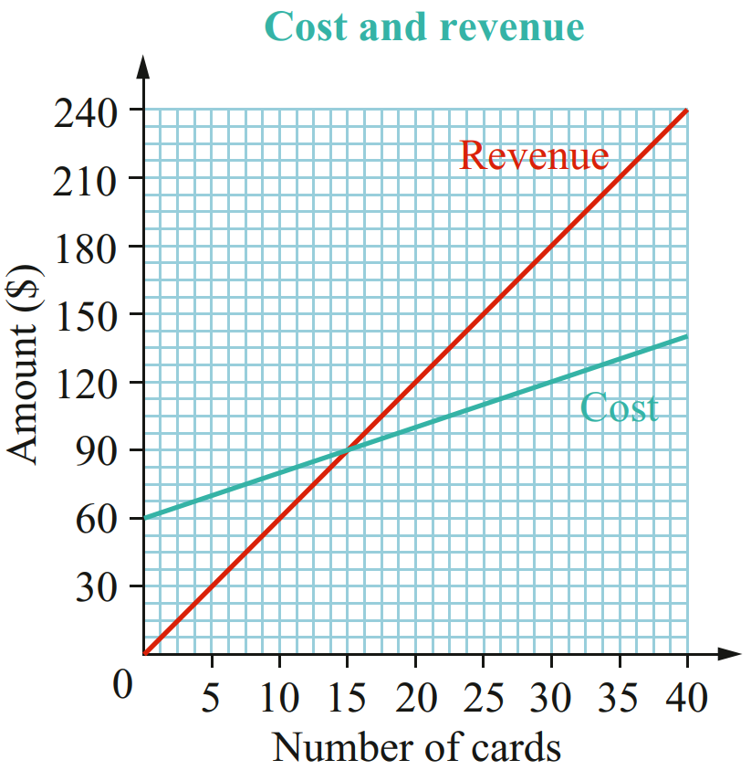
- Suzy makes hand-painted cards. The production cost and the revenue generated by the sale of the cards can be modelled with two linear equations and shown on a graph.
  - In business, “breaking even” means that revenue from selling items is equal to the cost of producing the items. How many cards does Suzy need to sell to break even?

15
  - What is the revenue at this break-even point?

$$\$90$$

Mastery
- Jayden and Ruby are saving all their money for the school ski trip.
- Jayden has saved $24 and earns $6 per hour mowing lawns.
- Ruby has saved $10 and earns $8 per hour babysitting.
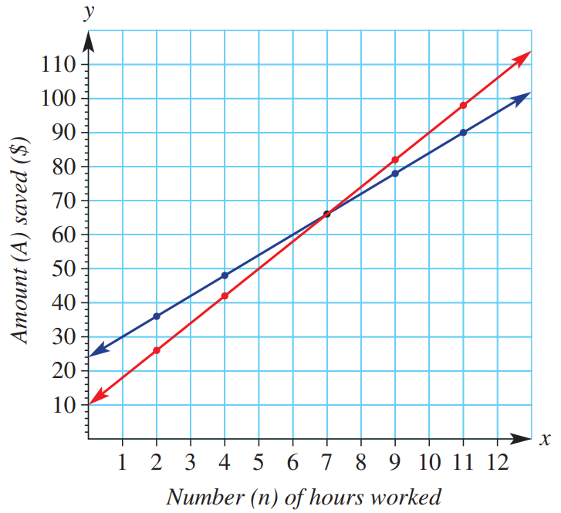

  - The two graphs represent Jayden and Ruby’s savings over time.
Which line represents Jayden, and which line represents Ruby? Why?

Jayden is blue, his line has gradient 6 ($6/hour) and $y$-int 24 ($24 initially)
Ruby is red, her line has gradient 8 ($8/hour) and $y$-int 10 ($10 initially)
  - Use the appropriate line on the graph above to find the solution to the following equations. Do not solve using the inverse operations method. Solve graphically.
$$10+8n=42$$  $$n=4$$ | $$24+6n=48$$  $$n=4$$ | $$10+8n=66$$  $$n=7$$
$$24+6n=66$$  $$n=7$$ | $$10+8n=98$$  $$n=11$$ | $$24+6n=90$$  $$n=11$$
  - Write the coordinates of the point of intersection.
Show that these values satisfy both Ruby and Jayden’s equations.

$$\left(7,66\right)$$
  - Identify how many hours have been worked and what their savings are at the point of intersection of the two lines.

7 hours of work, $66 in savings

- Jessica and Max have a 10-second running race.
- Max runs at 6 m/s.
- Jessica is given a 10 m head start and runs at 4 m/s.
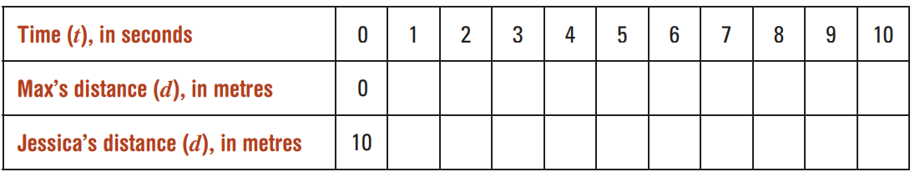
  - Complete the table of values.

  - Plot these points on a distance–time graph and join them to form two straight lines, labelling them ‘Jessica’ and ‘Max’.
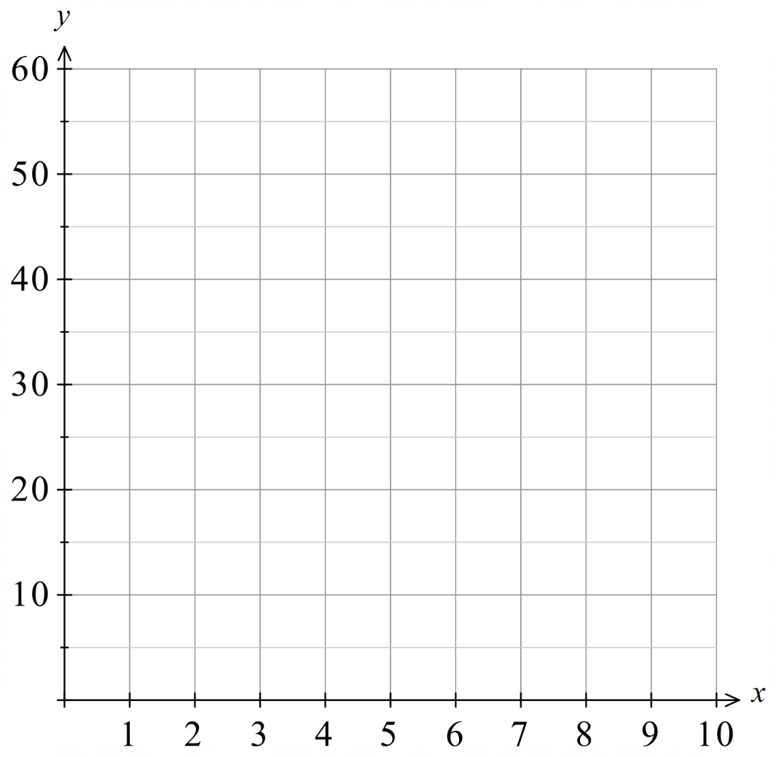

  - Write the solution $(t, d)$ that is true for both distance equations and show that it satisfies both equations.

$$\left(5,30\right)$$
  - Explain what is happening in the race at the point of intersection, and for each athlete state the distance from the starting line and time taken.

After 5 seconds, both athletes are 30 m from the starting point, i.e., they pass each other.
- 2017 HSC Standard 2 Band 4
The graph of the line with equation $y=6-2x$ is shown. When the graph of the line with equation $y=x+3$ is also drawn on the number plane, what will be the point of intersection?
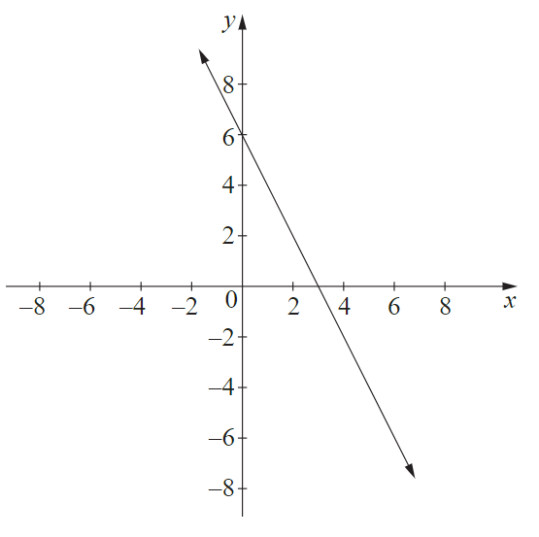
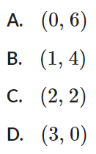

B
- HSC Standard 2 Sample Question Band 4
A computer application was used to draw the graphs of the equations:
$$x+y=4 and x-y=4$$
Which row of the table correctly matches the equations with the lines drawn and identifies the solution when the equations are solved simultaneously?
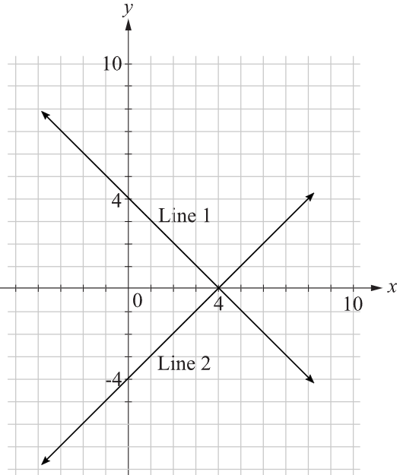
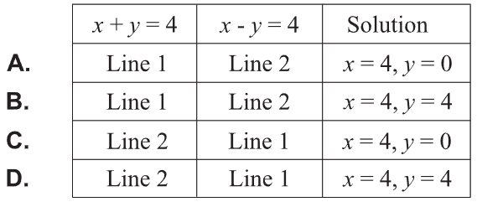

A

- HSC Standard 2 Sample Question Band 4
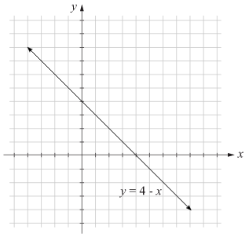
The graph of the line $y=4-x$ is shown.
By graphing $y=2x+1$ on the grid provided, find the simultaneous solution.

$$\left(1,3\right)$$
- HSC Sample Question Band 4
A student was asked to solve the following simultaneous equations.
$y=2x-8$
$x-4y+3=0$
After graphing the equations, the student found the point of intersection to be (5,2).
Is the student correct? Support your answer with mathematical reasoning.

Yes, (5,2) satisfies both equations.

Solving by Substitution

- Review
- Solve linear equations
- $-x=2x+3$ | - $2x-3\left(x+3\right)=-8$
- $3x+2\left(24-4x\right)=29$ | - $4x+$ $\frac{x-3}{2}$ $=24$

- Substitute an expression into another
Substitution replaces a variable in an expression with a number, or another expression.
Substitute, using the given information:
- $y=2x+3$; $y=5$ | - $y=2x+3;$ $y=5$
- $y=2x+3$; $y=5x$ | - $y=2x+3;$ $y=5x+7$
- $y=$ $\frac{x}{2}$; $y=5x+7$ | - $y=3x+7;$ $y=$ $\frac{x+5}{2}$

- Solving Simultaneous Equations by Substitution
The goal is to form an equation with only one pronumeral, solve it, then use that value to find the other.
- Substitute into the other equation.
- Solve for the pronumeral.
- Substitute the solution back into either equation to find the other pronumeral.

- Label each equation so you can track which equation you are substituting into.

- Example Solve simultaneous equations by substitution
$y=2x+3$ (1)
$y=-x$ (2)
1. Sub (2) into (1)  $$-x=2x+3$$2. $-3x=3$  $x=-1$ | 3. Sub $x=-1$ into (2)  $y=-\left(-1\right)$  $=1$  $∴x=-1, y=1$

- Guided Practice
$y=2x$ (1)
$y=3x-5$ (2)

$$x=5,y=10$$
$2x-3y=-8$ (1)
$x=y-3$ (2)

$$x=-1, y=2$$
$y=1-2x$ (1)
$2y=x+14$ (2)

$$x=-\frac{12}{5},y=\frac{29}{5}$$
- Solving Simultaneous Equations by Substitution
- Rearrange one equation to make $x$ or $y$ the subject.
Choose the equation that avoids fractions.
- Substitute into the other equation.
- Solve for the pronumeral.
- Substitute the solution back into either equation to find the other pronumeral.

- Label each equation so you can track which equation you are substituting into.

- Example Solve simultaneous equations by substitution
$3x-2y=29$ (1)
$4x+y=24$ (2)
0. Rearrange (2) for $y$  $y=24-4x$ (3)  1. Sub $(3)$ into (1)  $3x-2\left(24-4x\right)=29$  2. $3x-48+8x=29$  $11x=77$  $x=7$ | 3. Sub $x=7$ into (3)  $y=24-4\left(7\right)$  $=-4$  $∴x=7, y=-4$

- Guided Practice
$2x+2y=14$ (1)
$y-x=3$ (2)

$$x=2,y=5$$
$3y=9x$ (1)
$2y=4x+5$ (2)

$$x=\frac{5}{2}, y=\frac{15}{2}$$

Foundation
- Solve these equations by substitution.
- $y=3x+12$  $y=2x+5$  $$\left(-7,-9\right)$$ | - $y=5x-8$  $y=3x-4$  $$\left(2,2\right)$$ | - $y=-4x+10$  $y=-2x+6$  $$\left(2,2\right)$$
- $y=-2x+15$  $y=-3x+21$  $$\left(6,3\right)$$ | - $y=2x-18$  $y=6x-30$  $$\left(3,-12\right)$$ | - $y=30+6x$  $y=-2x+18$  $$\left(-\frac{3}{2},21\right)$$
- $y=x+5$  $$3x+y=13$$  $$\left(2,7\right)$$ | - $y=x-1$  $$3x+2y=8$$  $$\left(2,1\right)$$ | - $x=2y+3$  $$11y-5x=-14$$  $$\left(5,1\right)$$
- $x=3y-5$  $$3y+5x=11$$  $$\left(1,2\right)$$ | - $y=5-2x$  $$y=\frac{3}{2}x-2$$  $$\left(2,1\right)$$ | - $y=5x-1$  $$y=\frac{11-3x}{2}$$  $$\left(1,4\right)$$
- $y+2x=-18$  $y+6x=30$  $$\left(12,-42\right)$$ | - $2x+y=-18$  $6x-y=-30$  $$\left(-6,-6\right)$$ | - $2x+3y=8$  $4x-y=7$  $$\left(\frac{29}{14}, \frac{9}{7}\right)$$
- $2x-y=9$  $$3x-7y=19$$  $$\left(4,-1\right)$$ | - $4x-5y=2$  $$x+10y=41$$  $$\left(5,\frac{18}{5}\right)$$ | - $2x+3y=47$  $$4x-y=45$$  $$\left(13,7\right)$$

Development
- Read the example carefully and answer the questions.
Dom’s work:  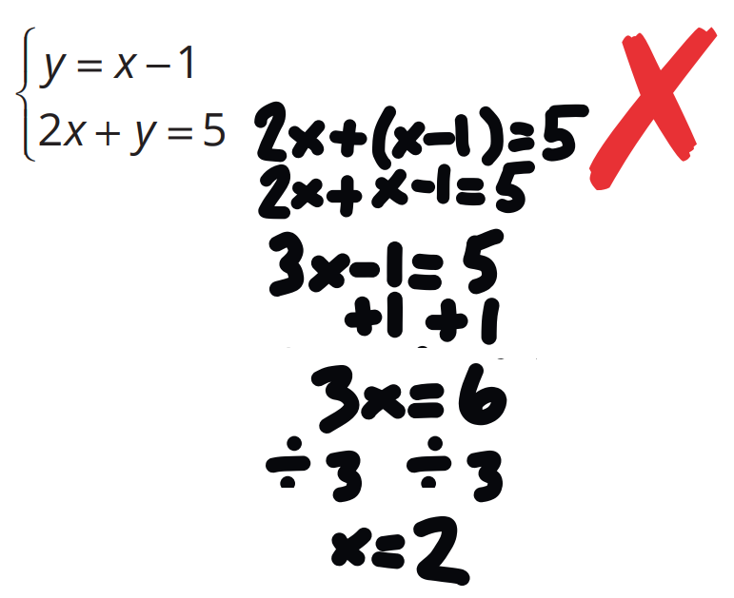 | Dom’s working out is correct, but his answer is incomplete.  What else does he need to do to finish solving the equations simultaneously?  Find the $y$-value  Solve simultaneously:  $x=1-y$  $2x-y=5$  $$\left(2,-1\right)$$

- The salary structures for companies A and B are given by:
Company A: $20 per hour
Company B: $45 plus $15 per hour
  - Find a rule for $$E$ earned in $t$ hours for:
    - Company A
$$E=20t$$
    - Company B
$$E=45+15t$$
  - Solve your two simultaneous equations from part a.

$$\left(9,180\right)$$
  - State the number of hours worked for which the earnings are the same for the two companies.
9 hours
  - State the amount earned when the earnings are the same for the two companies.
$180
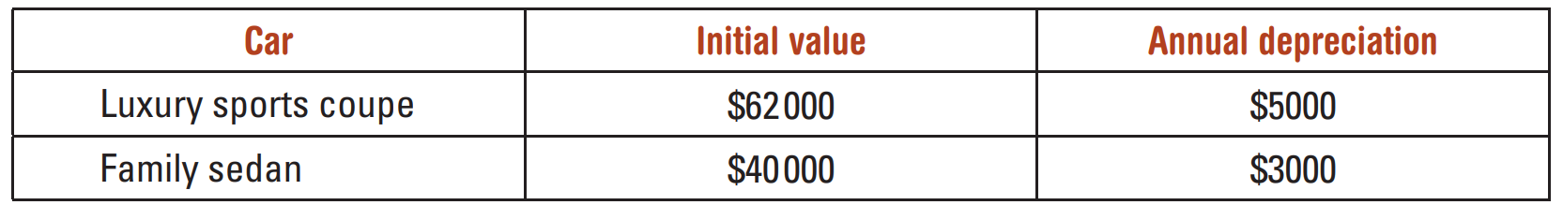
- The value of two cars is depreciating (i.e. decreasing) at a constant rate according to the information in this table.

  - Find a rule for value $$V$ after $t$ years for:
    - Luxury sports coupe
$$y=62000-5000x$$
    - Family Sedan
$$y=40000-3000x$$
  - Solve your two simultaneous equations from part a.

$$\left(11,7000\right)$$
  - State the time taken for the cars to have the same value.
11 years
  - State the value of the cars when they have the same value
$7000
- Solve by substitution:
- $y=x^{2}+3$  $y=2x+2$  $$\left(1,4\right)$$ | - $y=4x^{2}+20$  $$y=-20x-5$$  $$\left(-2.5, 45\right)$$
- Solve these non-linear equations simultaneously by substitution.
There are two possible sets of solutions.
- $x+y=15$  $x^{2}+y^{2}=125$  $\left(5,10\right)$ and $\left(10,5\right)$ | - $x-y=3$  $x^{2}+y^{2}=185$  $\left(-8, -11\right)$ and $\left(11,8\right)$ | - $2x+y=5$  $4x^{2}+y^{2}=17$  $\left(\frac{1}{2}, 4\right)$ and $\left(2, 1\right)$
- $x+y=9$  $x^{2}+xy+y^{2}=61$  $\left(4,5\right)$ and $\left(5,4\right)$ | - $x+2y=5$  $2xy-x^{2}=3$  $\left(1,2\right)$ and $\left(\frac{3}{2},\frac{7}{4}\right)$ | - $3x+2y=16$  $xy=10$  $\left(2,5\right)$ and $\left(\frac{10}{3},3\right)$

Mastery
- In a multiple choice test, 8 marks are awarded for each correct answer and 5 marks are subtracted for each incorrect answer.
  - If after 26 questions are answered, Kevin scored 0, how many questions did he answer correctly?
Let $c$ = correct answers,
$26-c$ = incorrect.
$8c-5(26-c)=0$
$13c=130$, $c=10$.
Kevin answered 10 correctly.
  - If a test has 50 questions and every question is answered, how many have to be correct to score at least 20 marks?
Let $c$ = correct answers.
$8c-5(50-c)≥20$
$13c≥270$,
$c≥20.8$.
At least 21 correct answers required.

- Mrs Funny tried to weigh her baby Jessica, but as the baby would not keep still she had to resort to other methods. She held Jessica while her older daughter, Melissa, read the scale to be 72 kg. Then Melissa held Jessica while Mrs Funny read the scale as 48 kg. Finally Mrs Funny held Melissa, while baby Jessica read the scale as 102 kg.
  - Find the combined weight of Mrs Funny, Melissa and Jessica.

(1) $F+J=72$
(2) $M+J=48$
(3) $F+M=102$
Add (1), (2) and (3): $2(F+M+J)=222$, so $F+M+J=111$ kg.

  - What is the weight of baby Jessica?

Sub (3) into total: $J=111-102=9$. Jessica weighs 9 kg.

- Grandma Betty spent $\$100$ buying Christmas presents and cards for friends and relatives in one shop and bought altogether 100 items. She bought books for $\$10$ each, pens for $\$2$ each and cards for 50 cents each. How many of each did she buy? There are two possible answers.

Let $x$ = books, $y$ = pens, $z$ = cards.
(1) $x+y+z=100$
(2) $10x+2y+0.5z=100$
Sub $z=100-x-y$ from (1) into (2) and simplify:
$19x+3y=100$.
By trial and error: $(x,y,z)=(1,27,72)$ or $(4,8,88)$.

Solving by Elimination (No Adjustment)

- Add and Subtract equations
We can add and subtract entire equations.
When subtracting, use brackets to keep track of the sign.
$$2x + 3y = 11$$  $$+ \left(4x - 3y = 7\right)$$  ──────── |  |  | $$3x + 5y = 22$$  $$+ \left(7x - 5y = 18\right)$$  ────────
$$4x + 3y = 17$$  $$- \left(x + 3y = 8\right)$$  ──────── |  |  | $$5x - 2y = 11$$  $$- \left(2x - 2y = 5\right)$$  ────────
- $3x + 4y = 13$ (1)  $5x - 4y = 11$ (2)  Find $(1) + (2)$ |  |  | - $6x + 2y = 20$ (1)  $x + 2y = 5$ (2)  Find $\left(1\right)- (2)$
- $-3x + 4y = 6$ (1)  $3x + 2y = 12$ (2)  Find $(1) + (2)$ |  |  | - $5x - 3y = 14$ (1)  $2x - 3y = 5$ (2)  Find $\left(1\right)- (2)$
- Identify whether to add or subtract two equations
Our goal when solving simultaneous equations is to first form an equation that only has one variable. We can do this by adding or subtracting two equations.
To eliminate a variable, their coefficients must have the same magnitude.
If the coefficients have the same sign, subtract. If the coefficients have different signs, add.
✖  $$2x + 3y = 11 \\ 3x +2y = 15$$  Cannot eliminate | ✔  $$2x + 3y = 11 \\ 2x +2y = 15$$  subtract equations to eliminate $x$ |  | ✔  $$2x + 3y = 11 \\ -2x +2y = 15$$  add equations to eliminate $x$ |  | ✔  $$2x + 3y = 11 \\ -5x-3y = 15$$  add equations to eliminate $y$
Decide whether to add or subtract these equations to eliminate a variable.
- $3x+5y=22$  $$7x-5y=18$$ |  | - $3x+4y=19$  $$7x-4y=21$$ |  | - $3x+5y=22$  $$7x+5y=38$$
- $5x-3y=17$  $$2x+3y=25$$ |  | - $4x+6y=11$  $$4x+5y=20$$ |  | - $3x-5y=35$  $$5y-5x=38$$

- Solving Simultaneous Equations by Elimination (No Adjustment)
The goal is to form an equation with only one pronumeral, solve it, then use that value to find the other.
- Add or subtract the equations to eliminate one of the variables.
- Solve for the pronumeral.
- Substitute the solution back into either equation to find the other pronumeral.

- Example Solve simultaneous equations by elimination (No Adjustment)
$-6x+2y=2$ (1)
$5x+2y=13$ (2)
1. $(1)-(2)$:  $$2y-6x=2 \\ - (2y+5x=13)$$  _____________________________________  $-11x=-11$  2. $x=1$ | 3. Sub $x=1$ into (1)  $2y-3\left(1\right)=1$  $y-3=1$  $y=4$  $$∴x=1,y=4$$

- Guided Practice
$x+y=6$ (1)
$3x-y=10$ (2)

$$x=4,y=2$$
$x-y=-2$ (1)
$x+y=4$ (2)

$$x=1,y=3$$
$2x+3y=-14$ (1)
$x+3y=-4$ (2)

$$x=-10, y=2$$

Foundation
- Decide whether the two equations should be added or subtracted to eliminate a variable.
- $3x+4y=10$  $5x+4y=22$  add | subtract  subtract | - $-3x-4y=-10$  $-5x-4y=-22$  add | subtract  subtract
- $3x+4y=10$  $5x+4y=-22$  add | subtract  subtract | - $-3x-4y=-10$  $-5x+4y=-22$  add | subtract  add
- $3x+4y=10$  $-5x-4y=-22$  add | subtract  add | - $5x-2y=-10$  $5x+4y=-22$  add | subtract  subtract
- $3x+4y=10$  $-5x-4y=-22$  add | subtract  add | - $-5x-2y=-10$  $5x+4y=-22$  add | subtract  add
- $3x+4y=-10$  $-5x-4y=-22$  add | subtract  add | - $5x-2y=-10$  $-5x+4y=-22$  add | subtract  add
- $-3x+4y=-10$  $-5x-4y=-22$  add | subtract  add | - $-5x-2y=-10$  $-5x+4y=-22$  add | subtract  subtract

- Use the elimination method to solve these equations. Follow the setting out shown.
 | System of Equations | Solve for first variable | Solve for second variable
 | $$3x-y=1 (1) \\ x+y=3 (2)$$ | $\left(1\right)+\left(2\right):$  $$3x-y=1 \\ + (x+y=3)$$  ______________________________  $4x=4$  $x=1$ | Sub $x=1$ into $(3)$  $$1+y=3 \\ y=2$$
 | $$2x-y=2 (1) \\ x+y=7 (2)$$ | $\left(1\right)+\left(2\right):$  $$2x-y=2 \\ + (x+y=7)$$  ______________________________ | $$x=3,y=4$$
 | $$4x+y=9 (1) \\ 2x-y=3 (2)$$ | $\left(1\right)+\left(2\right):$ | $$x=2,y=1$$
 | $$-x+2y=7 (1) \\ x+y=4 (2)$$ |  | $$x=\frac{1}{3}, y=\frac{11}{3}$$
 | $$2x+y=7 (1) \\ x+y=4 (2)$$ | $\left(1\right)-\left(2\right):$  $$2x+y=7 \\ - (x+y=4)$$  ______________________________ | $$x=3,y=1$$
 | $$3x+y=9 (1) \\ 2x+y=7 (2)$$ | $\left(1\right)-\left(2\right):$ | $$x=2,y=3$$
 | $$5x-2y=13 (1) \\ 3x+2y=3 (2)$$ |  | $$x=2,y=-\frac{3}{2}$$

Development
- Solve these equations using the elimination method.
- $2x+3y=18$  $6x+3y=30$  $$x=3,y=4$$ | - $2x+3y=18$  $6x-3y=30$  $$x=6,y=2$$ | - $2x+y=18$  $6x-y=30$  $$x=6,y=6$$
- $2x-y=18$  $$6x-y=30$$  $$x=3,y=-12$$ | - $y+2x=18$  $y+6x=30$  $$x=3,y=12$$ | - $y+2x=-18$  $y+6x=30$  $$x=12,y=-42$$
- $2x+y=-18$  $6x-y=-30$  $$x=-6,y=-6$$ | - $2x+4y=-18$  $2x-4y=-30$  $$x=-12,y=\frac{3}{2}$$ | - $x+4y=-18$  $2x-4y=-30$  $$x=-16,y=-\frac{1}{2}$$

Solving by Elimination (Adjustment Required)

- Multiply equations
We can multiply both sides of equations to get an equivalent equation.
- $3x+2y=10 ×2 →$

- $4x - 3y = 11 ×2 →$

- $2x + 5y = 13 ×3→$

- $5x - 2y = 8 ×3→$

- $4x - y = 9 ×4→$

- Identify multiplier
Our goal when solving simultaneous equations is to first form an equation that only has one variable. We can do this by adding or subtracting two equations.
To eliminate a variable, their coefficients must have the same magnitude.
Use the LCM of the coefficients to find the multiplier.
Choose which equation to multiply so that one variable has coefficients of equal magnitude.
- $3x+2y=7$  $$5x+y=7$$ | - $15x+2y=27$  $3x+7y=45$
- $3x-2y=29$  $$4x+5y=8$$ | - $3x+5y=22$  $$2x+7y=33$$
- $3x-2y=29$  $$4x+5y=8$$ | - $3x+5y=22$  $$2x-7y=33$$

- Solve Simultaneous Equations by Elimination (With Adjustment)
- Multiply one or both equations so that one variable has coefficients of equal magnitude.
- Add or subtract the equations to eliminate one variable.
- Solve for the remaining variable.
- Substitute the solution into either original equation to find the other variable.

- Example Solve simultaneous equations by elimination (with adjustment)
$3x-2y=29$ (1)
$4x+5y=8$ (2)
1. $\left(1\right)×4→12x-8y=116$ (3)  $\left(2\right)×3→12x+15y=24$ (4)  2. $\left(3\right)-\left(4\right):$  $$12x+15y=24 \\ - (12x-8y=116)$$  ________________________________________  $$23y=-92$$  3. $y=-4$ | 4. Sub $y=-4$ into $\left(1\right)$  $$3x-2\left(-4\right)=29$$  $$3x+8=29$$  $$3x=21$$  $$x=7$$  $∴x=7, y=-4$

- Guided Practice
$3x+2y=7$ (1)
$5x+y=7$ (2)

$$x=1, y=2$$
$15x+2y=27$ (1)
$3x+7y=45$ (2)

$$x=1,y=6$$
$3x+5y=22$ (1)
$2x+7y=33$ (2)

$$x=-1,y=5$$

Foundation
- Decide what to multiply each equation by to eliminate the $y$ variable.
- $3x+y=10$ $×$ ……  4  $5x+4y=22$ $×1$ (don’t adjust) | - $4x-3y=-10$ $×$ ……  1  $5x-y=22$ $×$ ……  3
- $3x+4y=10$ $×$ ……  1  $5x+y=22$ $×$ ……  4 | - $4x-3y=-10$ $×$ ……  2  $5x-2y=22$ $×$ ……  3
- $3x+3y=10$ $×$ ……  1  $5x+y=22$ $×$ ……  3 | - $4x-6y=-10$ $×$ ……  1  $5x-2y=22$ $×$ ……  3
- $4x+3y=10$ $×$ ……  1  $5x+y=22$ $×$ ……  3 | - $4x-6y=-10$ $×$ ……  2  $5x-4y=22$ $×$ ……  3
- $4x+3y=-10$ $×$ ……  1  $5x+y=-22$ $×$ ……  3 | - $4x+6y=-10$ $×$ ……  2  $5x-4y=22$ $×$ ……  3
- $4x-3y=-10$ $×$ ……  1  $5x+y=22$ $×$ ……  3 | - $4x+6y=-10$ $×$ ……  5  $5x-5y=22$ $×$ ……  6

- Read the example carefully and answer the questions.
Natalie’s work:  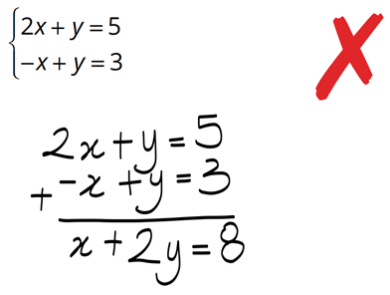 | Natalie tried to add the two equations and got stuck. She should have subtracted.  How would subtracting have gotten her closer to solving the equations?  Subtracting would eliminate $y$  Solve simultaneously:  $3x+3y=15$  $2x+3y=12$  $$x=3.y=2$$
- Use the elimination method to solve these equations simultaneously.
 | System of Equations | Scaled | Solve for first variable | Solve for second variable
 | $$5x+2y=11 (1) \\ 3x-4y=4 (2)$$ | $$×2→10x+4y=22 (3) \\ 3x-4y=4$$ | $\left(3\right)+\left(2\right):$  $$10x+4y=22 \\ + (3x-4y)=4$$  ______________________________  $13x=26$  $x=2$ | Sub $x=2$ into $(1)$  $$5\left(2\right)+2y=11 \\ 10+2y=11 \\ 2y=1 \\ y=0.5$$
 | $$3x+2y=8 (1) \\ 2x-y=3 (2)$$ | $3x+2y=8$  $×2→$ $(3)$ | $\left(1\right)+\left(3\right):$ | $$x=2,y=1$$
 | $$3x+2y=11 (1) \\ 2x-y=-3 (2)$$ |  |  | $$x=\frac{5}{7},y=\frac{31}{7}$$
 | $$2x+3y=11 (1) \\ 3x+y=13 (2)$$ |  |  | $$x=4,y=1$$
 | $$2x-3y=8 (1) \\ x-5y=11 (2)$$ |  |  | $$x=1,y=-2$$
 | $$x+6y=0 (1) \\ 3x-2y=-10 (2)$$ |  |  | $$x=-3,y=\frac{1}{2}$$
 | $$5x-4y=24 (1) \\ 2x=y+9 (2)$$ |  |  | $$x=4,y=-1$$

- Use the elimination method to solve these equations simultaneously.
 | System of Equations | Scaled | Solve for first variable | Solve for second variable
 | $$10x+3y=5 (1) \\ 3x-2y=16 (2)$$ | $$×2→20x+6y=10 (3)$$  $$×3→9x-6y=48 (4)$$ | $\left(3\right)+\left(4\right):$  $$20x+6y=10 \\ + \left(9x-6y\right)=48$$  ________________________________  $29x=58$  $x=2$ | Sub $x=2$ into $(1)$  $$x=2,y=-5$$
 | $$2x+3y=11 (1) \\ 3x+4y=20 (2)$$ |  |  | $$x=16,y=-7$$
 | $$3x+8y=27 (1) \\ 4x+3y=13 (2)$$ |  |  | $$x=1,y=3$$
 | $$2x+3y=14 (1) \\ 8x-5y=5 (2)$$ |  |  | $$x=\frac{5}{2},y=3$$
 | $$9x-4y=-20 (1) \\ 5x-6y=-13 (2)$$ |  |  | $$x=-2,y=\frac{1}{2}$$

Development
- Solve these equations simultaneously.
- $3x+2y=7$  $5x+y=7$  $$x=1,y=2$$ | - $3x+2y=0$  $2x-y=56$  $$x=16,y=-24$$ | - $5m+4n=22$  $m-5n=-13$  $$m=2,n=3$$
- $15x+2y=27$  $3x+7y=45$  $$x=1,y=6$$ | - $3a-4b=-16$  $2a+3b=12$  $$a=0,b=4$$ | - $3x-2y=11$  $4x+3y=43$  $$x=7,y=5$$
- $2x+3y=28$  $3x+2y=27$  $$x=5,y=6$$ | - $5p+2q+17=0$  $2p-3q+11=0$  $$p=-\frac{73}{19}, q=\frac{21}{19}$$ | - $-2h+3k=-14$  $2k=5h-13$  $$h=1,k=-4$$

Applications of Simultaneous Equations

- Apply Simultaneous Equations to Solve Problems
When a scenario has two variables that aren’t directly related to each other, we need to set up two equations and solve them simultaneously.
- Define the two variables.
- Set up two equations using information from the scenario.
- Solve the two equations simultaneously.
- Answer the question in words.

- Example Apply simultaneous equations to solve problems
The sum of the ages of two children is 17 and the difference in their ages is 5.
If Karla is the older sister of Alice, determine their ages.
1. Let $k$ be Karla’s age. Let $a$ be Alice’s age.  2. $k+a=17$ (1)  $k-a=5$ (2)  3. (1) $+$ (2): $2k=22$  $k=11$ | 3. (cont.) Sub $k=11$ into (1)  $11+b=17$  $b=6$  4. Karla is 11 and Alice is 6

- Guided Practice
The sum of the ages of two children is 24 and the difference between their ages is 8.
If Nikki is the older sister of Travis, determine their ages by setting up and solving a pair of simultaneous equations.
1. Let ……… be ………………………………
Let ……… be ………………………………
2. ……………………………… (1)
……………………………… (2)
3. Solving simultaneously:

4. Answer in words: ………………………………………………………………………………
Nikki: 16, Travis: 8
- Guided Practice
The perimeter of a rectangle is 56 cm. If the length of the rectangle is three times its breadth, determine the dimensions by setting up and solving two simultaneous equations.
1.

2.

3.

4.

Length: 21 cm, Width: 7 cm
Adult concert tickets cost $5 more than child tickets. Two adult tickets and two child tickets cost $70 in total. Find the cost of each ticket.
1.

2.

3.

4.

Child: $15, Adult: $20
- Guided Practice
John buys three daffodils and five petunias from the nursery and pays $25.
Julia buys four daffodils and three petunias for $26.
Determine the cost of each type of flower.

Petunias: $2, Daffodils: $5
Alex buys 4 bolts and 6 washers for $2.20 and Holly spends $1.80 on 3 bolts and 5 washers at the same local hardware store. Determine the costs of each bolt and each washer.

Bolt: $0.10, Washer: $0.30
A scientist mixes a 10% saline solution with a 30% saline solution to produce 200 mL of a 25% saline solution. Find the volume of each solution used.
Hint: Let $x=$ volume of 10% solution in mL,
$y=$ volume of 30% solution in mL.

50 mL of the 10% solution, 150 mL of the 30% solution.

Foundation
- Draw a line from the word problem to the appropriate pair of equations.
A

B

C

D

E
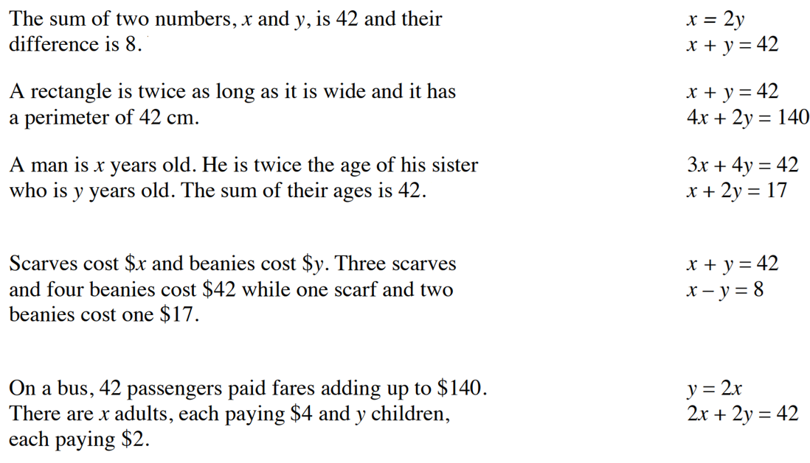

a – D, b – E, c – A, d – C, e - B
- The sum of two numbers is 1633 and their difference is 35.
Find the two numbers.

$$(1) x+y=1633$$
$$(2) x-y=35$$
$(1)+(2)$: $2x=1668$
$x=834$
$y=799$.
- Let the cost of an apple be $a$ and the cost of a banana be $b$.
  - One apple and one banana cost $1.25. Write an equation to describe this information.

$$a+b=1.25$$
  - Two apples and three bananas cost $3.25. Write an equation to describe this information.

$2a+3b=3.25$
  - Use parts a and b to find the cost of an apple and the cost of a banana.

Apple $0.50, banana $0.75
- The perimeter of a printed rectangular photo is 50 cm.
The length is 5 cm longer than the width. Use $l$ for length and $w$ for width.
  - Explain why $l+w=25$.
The perimeter is $2l+2w=50$, by dividing by 2, $l+w=25$
  - Explain why $l=w+5$.
Length is 5 cm longer than width: $l=w+5$.
  - Solve the two equations simultaneously and hence state the dimensions of the photo.

$$w=10, l=15$$
Width 10 cm, length 15 cm.


- 3 ducks and 4 tops cost $3.10 (1)
1 duck and 2 tops cost $1.30 (2)

What do these cost? Show your reasoning.
- 6 ducks and 8 tops?  $\left(1\right)×2=$  $(1)×2$: $6d+8t=\$6.20$ | - 4 ducks and 6 tops?  $(1)+(2)$: $4d+6t=\$4.40$
- 2 ducks and 2 tops?  $(1)-(2)$: $2d+2t=\$1.80$ | - 1 duck and 1 top?  $(c)÷2$: $d+t=\$0.90$
- 1 top?  $$\left(2\right)-\left(d\right):t=\$0.40$$ | - 1 duck?  $$\left(d\right)-\left(e\right)=d=\$0.50$$

Development
- At a cinema, a large drink costs $2 more than an ice cream. Ally buys five drinks and seven ice creams for $70. Let $d$ be the price of a drink and $c$ be price off an ice-cream.
  - Write two linear equations to model this information.

$$d=c+2$$
$$5d+7c=70$$
  - Solve the equations simultaneously to find the cost of each item.

$$c=5, d=7$$
Ice cream $5, drink $7.
- A thickshake is $2 more than a fruit juice.
If 3 thickshakes and 5 fruit juices cost $30, determine their individual prices.

Let $t$ = thickshake, $j$ = fruit juice.
$$\left(1\right) t=j+2$$
$$(2) 3t+5j=30$$
Sub (1) into (2): $3\left(j+2\right)+5j=30$
$$8j=24$$
$$j=3$$
$t=5$.
Fruit juice $3, thickshake $5.
- The cost of 1 apple and 1 banana at the school canteen is $1 and
the cost of 3 apples and 2 bananas is $2.40.
Find the cost of a single banana.

$$(1) a+b=1.00$$
$(2) 3a+2b=2.40$
$(2)-2×(1)$: $a=0.40$.
Sub into (1): $b=0.60$.
Banana costs $0.60.
- A paddock contains both ducks and sheep.
There are a total of 42 heads and 96 feet in the paddock.
How many ducks and how many sheep are in the paddock?

Let $d$ = ducks, $s$ = sheep.
$(1) d+s=42$,
$$(2) 2d+4s=96$$
$(2)-2×(1)$: $2s=12$
$s=6$
$d=36$.
36 ducks, 6 sheep.
- A factory produces items whose costs are $1000 plus $10 for every item.
The factory receives $60 for every item sold.
Write two equations, one for costs and one for revenue.
Find how many items must be sold for the factory to break-even (cost = revenue).

$$C=1000+10n$$
$$R=60n$$
Let $C=R$: $1000+10n=60n$
$50n=1000$
$n=20$.
Break-even at 20 items.
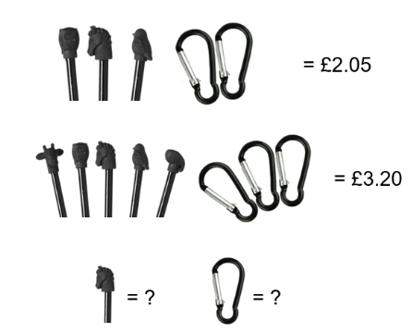
- 3 pencil-top erasers and 2 clips cost $2.05.

5 pencil-top erasers and 3 clips cost $3.20.

What is the cost of 1 pencil-top eraser and what is the cost of 1 clip?

Let $e$ = eraser
$c$ = clip.
$$(1) 3e+2c=2.05$$
$(2) 5e+3c=3.20$
$(1)×3$: $9e+6c=6.15$. $(2)×2$: $10e+6c=6.40$. Subtract: $e=0.25$.
Sub into (1): $c=0.65$.
Eraser $0.25
clip $0.65.
- A group of 5 adults and 3 children paid a total of $108 for their concert tickets.
Another group of 3 adults and 10 children paid $155.
Find the cost of an adult ticket and the cost of a child’s ticket.

$$(1) 5a+3c=108$$
$(2) 3a+10c=155$
$$\left(1\right)×10→50a+30c=1080$$
$\left(2\right)×3→$ $9a+30c=465$.
Subtract: $41a=615$
$a=15$.
Sub into (1): $c=11$.
Adult $15
child $11.
- A business has five times as many junior workers as it does senior workers.
If the weekly wage for a senior is $800 and for a junior is $600, find how many of each are employed if the total weekly wage bill is $57000.

Let $s$ = seniors, $j$ = juniors.
$$(1) j=5s$$
$$(2) 800s+600j=57000$$
Sub (1) into (2): $800s+3000s=57000$
$$s=15$$
$j=75$.
15 senior, 75 junior workers.
- Jasmine has $10 in 5-cent and 10-cent coins in her change jar and counts 157 coins in total.
How many 10-cent coins does she have?

$$\left(1\right) f+t=157$$
$$(2) 0.05f+0.1t=10$$
$(2)×20$: $f+2t=200$.
Subtract (1): $t=43$.
43 ten-cent coins.
- What are the lengths and widths of the congruent rectangles for each question?
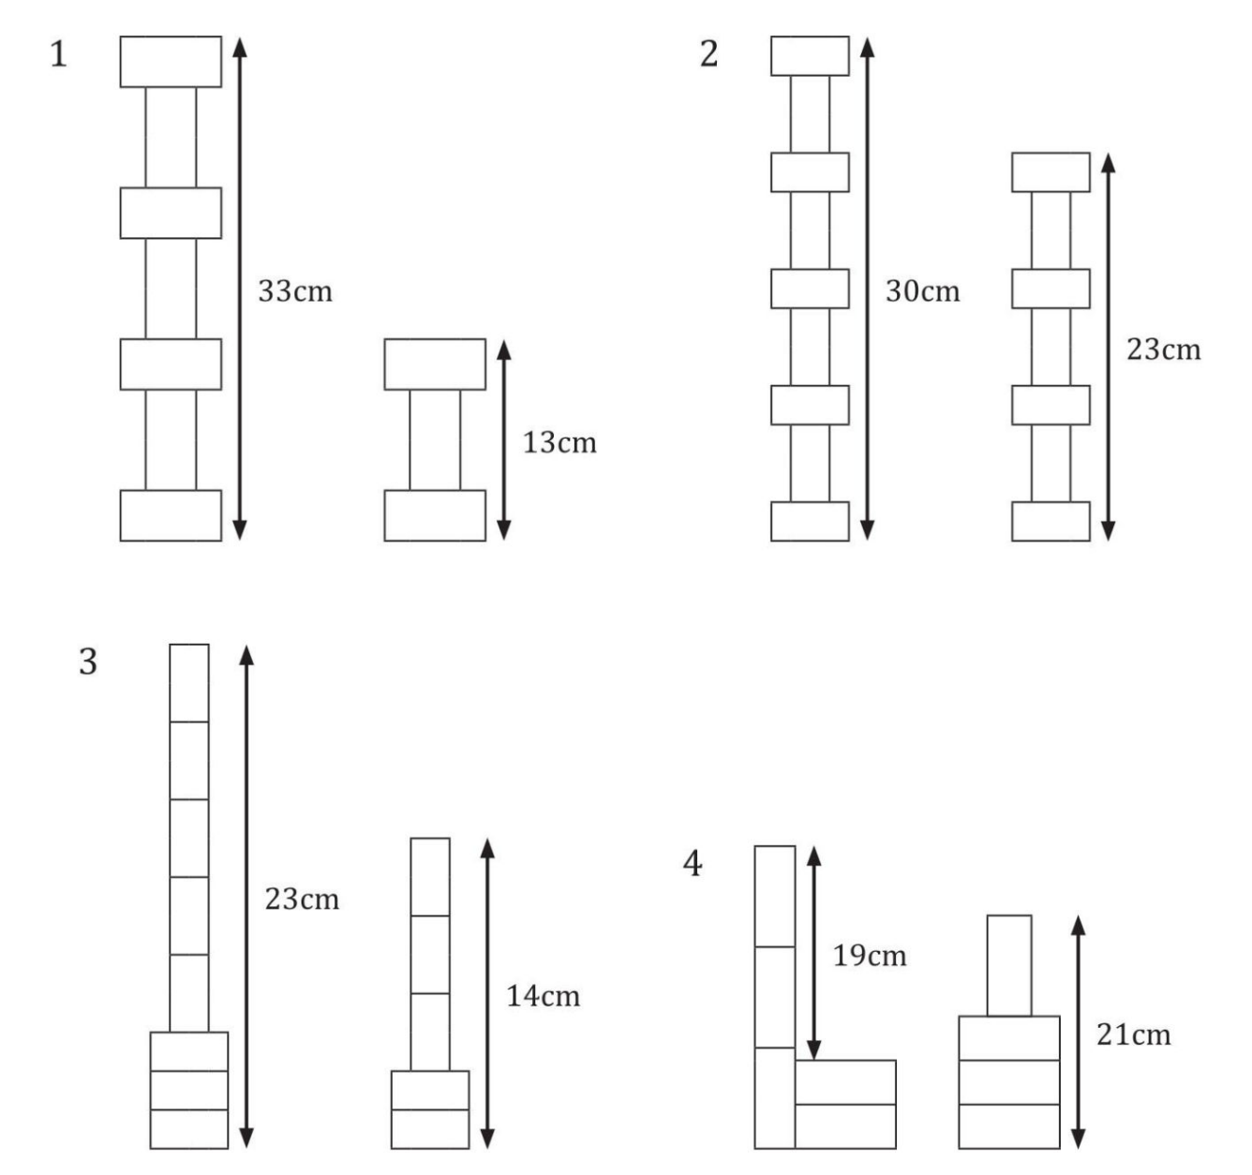  $3L+4W=33$ … (1)  $L+2W=13$ … (2)  $\left(2\right)×2:2L+4W=26$ (3)  $\left(1\right)-(3)$: $L=7$  $$W=3$$ | $$L=5$$  $$W=2$$
$$L=4$$  $$W=1$$ | $$W=4$$  $$L=9$$
- Olivia the fruiterer sells two fruit packs.
Pack 1: 10 apples and 5 mangoes ($12).
Pack 2: 15 apples and 4 mangoes ($14.15)
Determine the cost of 1 apple and 5 mangoes.

$$(1) 10a+5m=12$$
$(2) 15a+4m=14.15$
$\left(1\right)×4→40a+20m=48$.
$\left(2\right)×5→75a+20m=70.75$.
Subtract: $35a=22.75$
$a=0.65$.
Sub into (1): $5m=5.50$
$m=1.10$.
1 apple and 5 mangoes: $0.65+5(1.10)=\$6.15$.
- All the rectangles below are congruent.
They are placed on a coordinate grid and two points as shown.
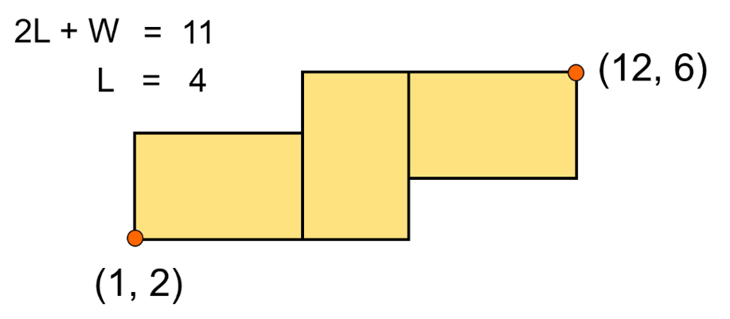
How long and wide are the rectangles?

$$L=4$$
$W=11-8=3$.
Length 4 cm
width 3 cm.
- The rectangles in each question are all congruent. How long and wide are each of these rectangles?
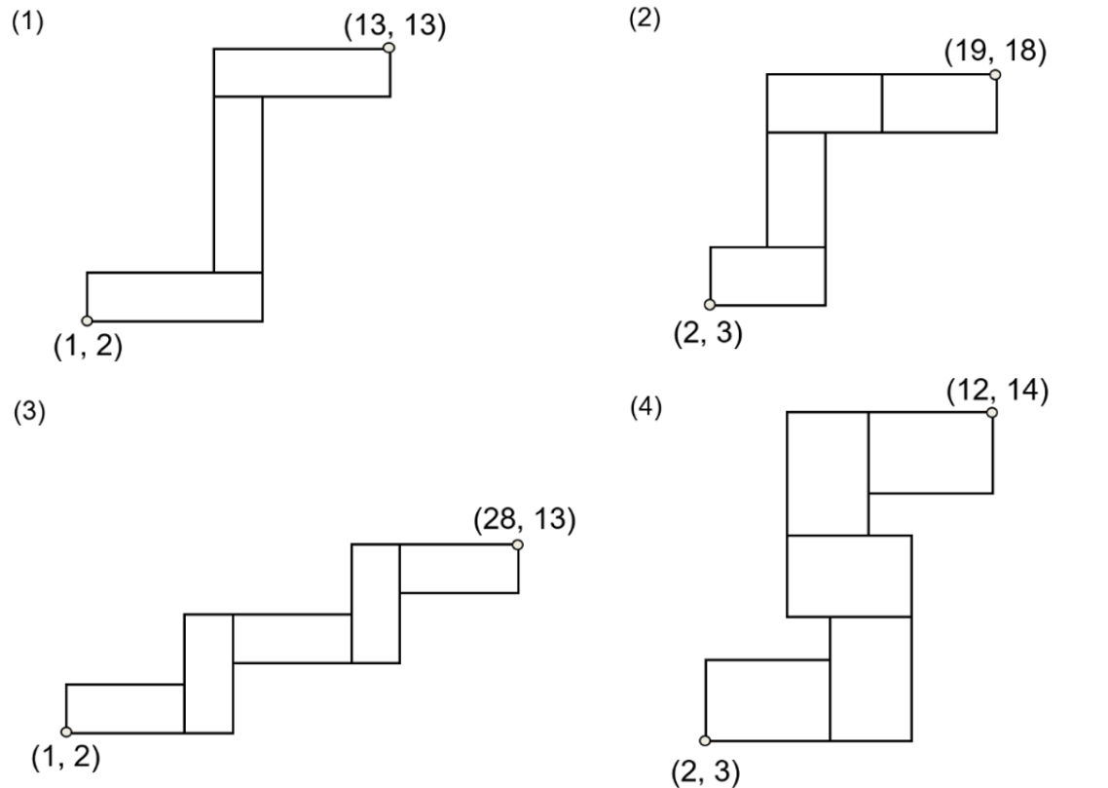  $$2L-W=12$$  $$L+2W=11$$  $$L=7, W=2$$ | $$3L-W=17$$  $$L+2W=15$$  $$L=7, W=4$$
- A new car with a petrol engine uses 10.0 L/ 100 km.
If the cost of petrol is $1.50/ L then the cost ($C) of fuel to drive the car is given by
$C=0.15d$, where $d$ is the distance travelled.
Another car costs $2000 more to purchase but only uses 6.0 L/ 100 km.
The cost of diesel fuel is $1.60/ L.
The cost of driving the diesel model of the car is given by $C=2000+0.096d$.
How far do you have to travel before the cost of the two models is the same?

Set costs equal: $0.15d=2000+0.096d$
$0.054d=2000$
$d≈37 037$ km.
- At present, Emma is 24 years older than her daughter. In 8 years’ time she will be 3 times her daughter’s age. What are Emma and her daughter’s present ages?

Let $x$ be Emma’s current age, $y$ be her daughter’s current age.
$$x=y+24$$
$$x+8=3\left(y+8\right)$$
Emma is 28 and her daughter is 4

- Sophie is currently 3 times her son’s age. In 14 years’ time, she will be twice her son’s age.
What is Sophie’s current age?

Let $x$ be Sophie’s current age, $y$ be Sophie’s son’s current age.
$$x=3y$$
$$x+14=2\left(y+14\right)$$
42
- Five years ago I was 5 times older than my son.
In 8 years’ time I will be 3 times older than my son.
How old am I today?

Let $x$ be my current age, $y$ be my son’s current age.
$$x-5=5\left(y-5\right)$$
$$x+8=3\left(y+8\right)$$
70 years old
- $△PQR$ is an equilateral triangle with side lengths shown in the diagram.
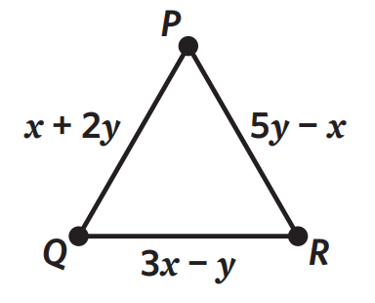
What​ is​ the value of 𝑥 and 𝑦​ if the perimeter is equal to 42?

Equilateral: all sides equal.
$x+2y=5y-x⇒2x-3y=0$ … (1)
Perimeter: $3(x+2y)=42⇒x+2y=14$
so $3x+6y=42$ … (2)
From (1): $x=3/2y$. Sub into (2): $9/2y+6y=42$
${21}/2y=42$
$y=4$
$x=6$.
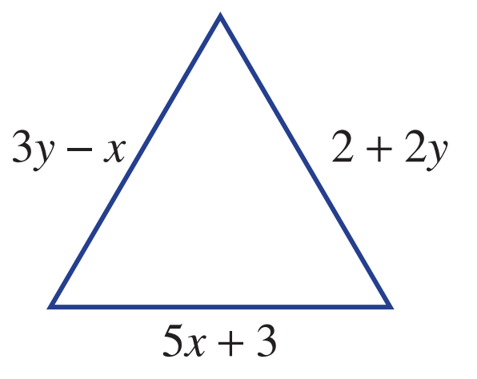
- Find the length of the sides of the equilateral triangle.

Equilateral: all sides equal.
$3y-x=2+2y⇒y-x=2$ … (1)
$3y-x=5x+3⇒3y-6x=3$ … (2)
From (1): $y=x+2$. Sub into (2):
$$3(x+2)-6x=3$$
$-3x=-3$
$x=1$
$y=3$.
Side length: $5(1)+3=8$ units.

Mastery
- Erin goes off on a long bike ride, averaging 10 km/h.
One hour later her brother Alistair starts chasing after her at 16 km/h.
How long will it take Alistair to catch up to Erin?

Let $t$ = time (hours) after Alistair starts.
Erin has 1 hour head start: $10(t+1)=16t$
$6t=10$
1 hr 40 mins
- Two ancient armies are about to battle each other.
The Egyptians are in town.
The Romans are 1 km away from the town.
The armies begin walking towards each other.
The Egyptians walk at a pace of 3 km/h and the Romans walk at a pace of 4km/h.
For how long will they walk before the battle begins?
(Hint: let the equations represent distance from the town; $d=st$).

Let $t$ = time in hours after both start walking. Distance from town:
Egyptians: $d=3t$. Romans: $d=1-4t$ (approaching from 1 km away).
1/7th of an hour, or 8 minutes 34 secs
- Four years ago Emily was twice Ally’s age. In four years’ time, Emily will be one and a quarter times Ally’s age. How old are Emily and Ally now?

Let $x$ be Emily’s current age, $y$ be Ally’s current age.
$$x-4=2\left(y-4\right)$$
$$x+4=1.25\left(y+4\right)$$
Emily is $9$ $\frac{1}{3}$ and Ally is $6$ $\frac{2}{3}$

- Molly has a bottle of 15% strength cordial and wants to make it stronger.
She adds an amount of 100% strength cordial to her bottle to make a total of 2000 mL of drink.
If the final strength of the drink is 25% cordial, find the amount of 100% strength cordial added.
Round your answer to the nearest mL.
Let $y$ be the volume (in mL) of initial 15% strength cordial in litres.
Let $x$ be the volume (in mL) of 100% strength cordial that Molly adds.

Let $x$ = volume of 100% cordial added (mL)
$y$ = initial 15% cordial volume (mL).
$$(1) x+y=2000$$
$(2) x+0.15y=0.25(2000)=500$
4/17 Litres $≈235$mL
- A fruit grower accidentally made a 5% strength chemical mixture to spray his grape vines.
The strength of spray should be 8%.
He then adds pure chemical until the strength reaches 8%. The final volume is 350 litres.
How much pure chemical did he have to add?

Let $x$ = pure chemical added (L)
$y$ = initial 5% mixture volume (L).
$$(1) x+y=350$$
$(2) x+0.05y=0.08(350)=28$
210/19 Litres $≈11.05$ L.
- In a two-digit number, the units digit is three times the tens digit.
When 36 is added to the number, the digits swap positions.
What is the original 2-digit number?
(Hint: a number can be written in terms of its digits in this way: $35=3\left(10\right)+5$; $ab=10a+b$)

Let the tens digit be $a$, units digit $b$.
$$(1) b=3a$$
$(2) 10a+b+36=10b+a$
26
- If 5 is added to both the numerator and denominator of a fraction, the result simplifies to $\frac{2}{3}$.
If 1 is subtracted from both the numerator and denominator, the result simplifies to $\frac{1}{3}$.
What was the original fraction?

Let numerator $=p$, denominator $=q$.
$$(1) \frac{p+5}{q+5}=\frac{2}{3}⇒3p+15=2q+10⇒3p-2q=-5$$
$$(2) \frac{p-1}{q-1}=\frac{1}{3}⇒3p-3=q-1⇒q=3p-2$$
$$\frac{3}{7}$$

- Two planes have the same size fuel tanks, but one will travel for 21 hours on a full tank and the other 35 hours on a full tank. They set off at the same time with full tanks and both planes burn fuel at a constant rate. After how long will one have 3 times as much fuel as the other?

Let plane A be plane that uses fuel faster (21 h)
Let plane B be plane that uses fuel slower (35 h)
Let the tank size be 105 units (the LCM of 21 and 35)
Plane A would burn fuel at 5 units per hour
Plane B would burn fuel at 3 units per hour
Fuel remaining in plane A at time $t$: $F_{A}=105-5t$
Fuel remaining in plane B at time $t$: $F_{B}=105-3t$
Set $F_{B}=3F_{A}$
$$105-3t=3\left(105-5t\right)$$
$$105-3t=315-15t$$
$$12t=210$$
$t=17.5$ hrs

Identities and Contradictions

- Investigation Types of equations
When asked to solve an equation, we usually work with conditional equations.
A conditional equation is true for specific values:
Solve $2x+4=8$

The solution of this equation is $x=$ ……, this means it is only true when $x=$ ……
This equation is an identity:
Solve $5(x+3)+2x-4=7x+11$

This equation is true for ……………………; all values of $x$ are …………………
This equation is a contradiction:
Solve $4x +5=2(2x-8)$

This equation is ………………… true; it has ……… solution.

- Identities and Contradictions
Identity  An identity is an equation that will always be true for all values of $x$.  $$2x+3=3+2x$$  If we graph $y=LHS$ and $y=RHS$, we will get two coincident lines.  Coincident lines are two lines that lie exactly on top of each other, meaning they have the same gradient and $y$-intercept.  $y=2x+3$ and $y=3+2x$  are two coincident lines  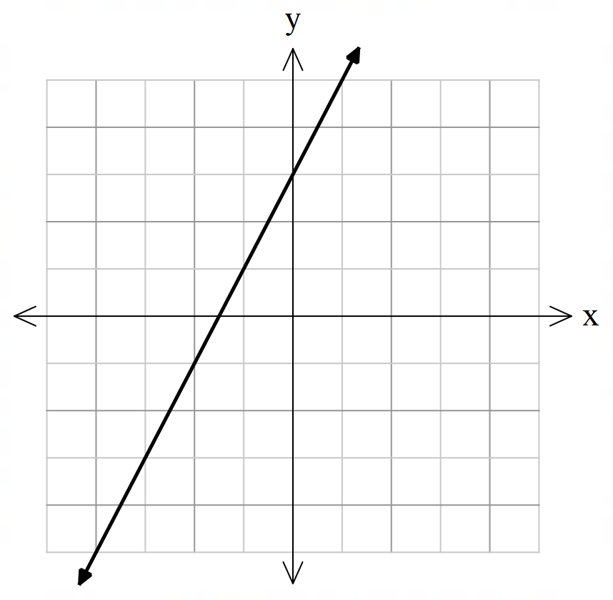  - Identities can be written with the ‘equivalent to’ symbol $≡$ | Contradiction  A contradiction is an equation that has no solution.  $$x+2=x-3$$  If we graph $y=LHS$ and $y=RHS$, we will get two parallel lines.  Parallel lines never intersect, meaning they have the same slope but different $y$-intercept.  $y=x+2$ and $y=x-3$  are two parallel lines.  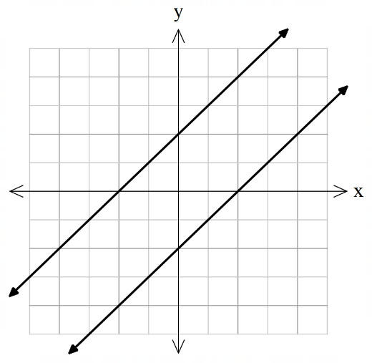  - Contradictions can be written with the ‘not equal to’ symbol $≠$

- Key Ideas
- If solving an equation leads to a true statement such as 0 = 0, the equation is an …………; if we graph $y=LHS$ and $y=RHS$, we will get two …………………… lines.
- If solving an equation leads to a single solution, such as $x=3$, the equation is a ……………… ………………
- If solving an equation leads to a false statement such as $-3=7$, the equation is a ……………………;
If we graph $y=LHS$ and $y=RHS$, we will get two …………………… lines.

Foundation
- State if the following is an identity, contradiction or conditional equation.
- $4x-1=4(x+1)$  Contradiction | - $-3(2x+1)-4x = -10(x+1)+7$  identity
- $2x-6+8x=10x-3+x$  conditional | - $3x+4=6x-11$  conditional
- $-x+15-3(x+1)=5-4x$  contradiction | - $5(x -1)=7x-2(x+1)-3$  identity
- $4(3p+6q)+6(4p-q)= 18(2p+ q)$  identity | - $3\left(3x-1\right)=9x+7$  contradiction
- If we graph $y=LHS$ and $y=RHS$ of an identity, the two lines are …………………
coincident
- If we graph $y=LHS$ and $y=RHS$ of a contradiction, the two lines are …………………
parallel
- Check your answers to Q1 by graphing $y=LHS$ and $y=RHS$ using DESMOS.

- If we graph $y=LHS$ and $y=RHS$ of a conditional equation, the two lines …………………………
………………………………………………………………………………………………………………
Intersect at exactly one point

Proving Identities

- Proving Identities
To prove an identity, start from one side of the equation and show it equals the other. You may also work on both sides separately and show they simplify to the same expression.
Do not apply operations to both sides or move terms across the equals sign; this assumes the identity is already true, which is what you are trying to prove.
Start from the side that gives you ‘more algebra’ to work with, usually the one that has more terms or operation; it is easier to simplify than to un-simplify.

- Example Prove identities algebraically
Prove that ${\left(x+3\right)}^{2}-9=x\left(x+6\right)$
$$LHS={\left(x+3\right)}^{2}-9 \\ =x^{2}+6x+9-9 \\ =x^{2}+6x \\ =x\left(x+6\right) \\ =RHS$$

- Guided Practice
Prove these identities.
- ${\left(x+5\right)}^{2}-25=x\left(x+10\right)$ | - $x^{2}=\left(x+3\right)\left(x-3\right)+9$
- $\frac{x^{2}-9}{x+3}$ $=x-3$ | - $\sqrt{x^{2}+12x+36}=x+6$

- Key Ideas
- To prove an identity, we start from the ………… or ………… and show it equals the other.
- We cannot apply ………………… to both sides or ………… terms from one side to the other, as this assumes the identity is true.

Foundation
- Prove these identities.
- $(x+5)(x-5)+25=x^{2}$  LHS $=(x+5)(x-5)+25$  $=x^{2}-25+25$  $$=x^{2}$$ | - ${\left(x+4\right)}^{2}-16=x\left(x+8\right)$  LHS $=(x+4)^{2}-16$  $=x^{2}+8x+16-16$  $=x^{2}+8x$  $=x(x+8)$
- ${\left(x+3\right)}^{2}-{\left(x-3\right)}^{2}=12x$  LHS$=(x^{2}+6x+9)-(x^{2}-6x+9)$  $=x^{2}+6x+9-x^{2}+6x-9$  $=12x$ | - ${\left(a+b\right)}^{2}-{\left(a-b\right)}^{2}=4ab$  LHS$=(a^{2}+2ab+b^{2})-(a^{2}-2ab+b^{2})$  $=a^{2}+2ab+b^{2}-a^{2}+2ab-b^{2}$  $=4ab$
- ${\left(x+h\right)}^{2}-x^{2}=h(2x+h)$  LHS $=x^{2}+2xh+h^{2}-x^{2}$  $=2xh+h^{2}$  $=h(2x+h)$ | - $x^{2}+2x+1-\left(x+1\right)=x(x+1)$  LHS$=x^{2}+2x+1-(x+1)$  $=(x+1)^{2}-(x+1)$  $=(x+1)\left[(x+1)-1\right]$  $=(x+1)(x)$  $=x(x+1)$
- $x^{3}-x=x(x-1)(x+1)$  LHS $=x^{3}-x$  $=x(x^{2}-1)$  $=x(x-1)(x+1)$ | - $x^{2}+6x+5=(x+3)²-4$  RHS$=(x+3)^{2}-4$  $=x^{2}+6x+9-4$  $=x^{2}+6x+5$
- $3x^{2}-6x+5=3(x-1)²+2$  RHS $=3(x-1)^{2}+2$  $=3(x^{2}-2x+1)+2$  $=3x^{2}-6x+3+2$  $=3x^{2}-6x+5$ | - $\frac{x^{2}+x}{x}=x+1, x≠0$  $$LHS =\frac{x^{2}+x}{x}$$  $$=\frac{x(x+1)}{x}$$  $=x+1$
- $\frac{1}{x}+\frac{1}{x+1}=\frac{2x+1}{x\left(x+1\right)}$ ,$x≠0,-1$  $$LHS =\frac{1}{x}+\frac{1}{x+1}$$  $$=\frac{x+1}{x(x+1)}+\frac{x}{x(x+1)}$$  $$=\frac{x+1+x}{x(x+1)}$$  $$=\frac{2x+1}{x(x+1)}$$ | - $\frac{1}{1-x}-\frac{1}{1+x}=\frac{2x}{1-x^{2}}$,$x≠±1$  $$LHS =\frac{1}{1-x}-\frac{1}{1+x}$$  $$=\frac{1+x}{(1-x)(1+x)}-\frac{1-x}{(1-x)(1+x)}$$  $$=\frac{(1+x)-(1-x)}{(1-x)(1+x)}$$  $$=\frac{2x}{1-x^{2}}$$
- $\frac{x+1}{x-1}-\frac{x-1}{x+1}=\frac{4x}{x^{2}-1}$, $x≠±1$  $$LHS =\frac{(x+1)^{2}}{(x-1)(x+1)}-\frac{(x-1)^{2}}{(x-1)(x+1)}$$  $$=\frac{(x+1)^{2}-(x-1)^{2}}{x^{2}-1}$$  $$=\frac{(x^{2}+2x+1)-(x^{2}-2x+1)}{x^{2}-1}$$  $$=\frac{4x}{x^{2}-1}$$ | - $\frac{1+x}{1-x}-\frac{1-x}{1+x}=\frac{4x}{1-x^{2}}$,$x≠±1$  $$LHS =\frac{(1+x)^{2}}{(1-x)(1+x)}-\frac{(1-x)^{2}}{(1-x)(1+x)}$$  $$=\frac{(1+x)^{2}-(1-x)^{2}}{1-x^{2}}$$  $$=\frac{(1+2x+x^{2})-(1-2x+x^{2})}{1-x^{2}}$$  $$=\frac{4x}{1-x^{2}}$$
- $\frac{x^{2}-4}{x^{2}+2x}=1-\frac{2}{x}$,$x≠0,-2$  $$LHS =\frac{x^{2}-4}{x^{2}+2x}$$  $$=\frac{(x-2)(x+2)}{x(x+2)}$$  $$=\frac{x-2}{x}$$  $$=\frac{x}{x}-\frac{2}{x}$$  $$=1-\frac{2}{x}$$ | - $x+\frac{1}{x}+2=\frac{{\left(x+1\right)}^{2}}{x}$,$x≠0$  $$RHS =\frac{(x+1)^{2}}{x}$$  $$=\frac{x^{2}+2x+1}{x}$$  $$=\frac{x^{2}}{x}+\frac{2x}{x}+\frac{1}{x}$$  $$=x+2+\frac{1}{x}$$
- $\frac{x^{2}+ 1}{x + 1}- \left(x - 1\right)=\frac{2}{x + 1}$,$x ≠ -1$  $$LHS =\frac{x^{2}+1}{x+1}-(x-1)$$  $$=\frac{x^{2}+1}{x+1}-\frac{(x-1)(x+1)}{x+1}$$  $$=\frac{x^{2}+1-(x^{2}-1)}{x+1}$$  $$=\frac{2}{x+1}$$ | - ${\left(\frac{x}{x + 1}\right)}^{2}+\frac{1}{{\left(x + 1\right)}^{2}}=\frac{x^{2}+ 1}{{\left(x + 1\right)}^{2}}$  $$LHS =\frac{x^{2}}{(x+1)^{2}}+\frac{1}{(x+1)^{2}}$$  $$=\frac{x^{2}+1}{(x+1)^{2}}$$

Equating Coefficients

- Equating Coefficients
Equating coefficients is a problem-solving strategy.
1. Expand out any brackets
2. Identify and set equal the coefficients of matching variables on both sides of an equation.
3. Find the value of the unknowns. You may need to use simultaneous equations.

- Example Find an unknown by equating coefficients
Given $a{\left(x+3\right)}^{2}-bx+5=4x^{2}+c$, Find $a,b,c$.
1. $a\left(x^{2}+6x+9\right)-bx+5=4x^{2}+c$  $$ax^{2}+6ax+9a-bx+5=4x^{2}+c$$  2. ¯ ¯¯ ¯¯ ¯¯¯ ¯¯¯ ¯ ¯  coefficients of $x^{2}$: $a=4$  coefficients of $x$: $6a-b=0$  constant terms: $9a+5=c$ | 3. Solve for unknowns  Substitute $a=4$ into two other equations.  $6\left(4\right)-b=0$, $b=24$  $9\left(4\right)+5=c$, $c=41$  $$a=4,b=24,c=41$$

- Guided Practice
Given that $(x+a)(x+b)=x^{2}+7x+12$, find $a$ and $b$.

$a=3, b=4$ or other way around
Find $a$, $b$, $c$ such that $ax\left(x+1\right)+bx+c=2x^{2}+x-3$.

$a=2, b=-1, c=-3$

Foundation
- Find the missing values by equating coefficients.
  - $\left(x+4\right)\left(x-6\right)+ax+b=x^{2}+8x-25$

$$a=10, b=-1$$
  - $\left(2x-5\right)\left(2x-7\right)+ax^{2}+b=3x^{2}-24x+12$

$$a=-1,b=-23$$
  - ${\left(x-2\right)}^{2}+x+a\left(x+b\right)=x^{2}+1$

$$a=3,b=-1$$
  - ${\left(x+b\right)}^{2}=x^{2}+cx+49$

$$if b=7, c=14 | if b=-7, c=-14$$
  - $\left(x+2c\right)\left(x+c\right)=x^{2}+dx+50$

$$if c=5, d=15 | if c=-5, d=-15$$

Development
- A parabola has the equation $y=x^{2}+2x+3$.
Find the values of $a$ and $c$ in the equation $y={\left(x-a\right)}^{2}+c$ and hence determine the coordinates of the vertex $\left(a,c\right)$.

$$\left(-1, 2\right)$$
- A rectangular prism has width $y$ cm, length $(x+a)$ cm and height $(x+b)$ cm,
where a and b are integers and $a>b$.
  - Show that the surface area of the rectangular prism is given by the expression
$2y\left(2x+a+b\right)+2(x+a)(x+b)$ cm²

  - If the surface area of the rectangular prism is equivalent to the expression $2y\left(2x+1\right)+2x^{2}+2x-12$ cm², find $a$ and $b$.

$$a=3,b=-2$$
- Find the value of $m$.
$$\left(x+3\right)\left(m-2\right)=-\frac{x}{3}-1$$

$$m=\frac{5}{3}$$

Mastery
- Write $\frac{x+3}{x+5}$ in the form $a+$ $\frac{b}{x+5}$.

$$1-\frac{2}{x+5}$$
- Write $3x^{2}+18x-5$ in the form $\frac{{\left(x-a\right)}^{2}+c}{b}$.

$$\frac{{\left(x+3\right)}^{2}-\frac{32}{3}}{\left(\frac{1}{3}\right)}$$
- Write $x^{2}+4x+y^{2}-2y$ in the form ${\left(x+a\right)}^{2}+{\left(y+b\right)}^{2}+c$.

$${\left(x+2\right)}^{2}+{\left(y-1\right)}^{2}-5$$
- $5x^{2}+px-8=q{\left(x-1\right)}^{2}+r$. Find $p,q,r$.

$$p=-10, q=5, r=-13$$

- Find the missing values by equating coefficients.
  - $4x^{3}+\left(x+a\right)\left(x+b\right)+cx=ax^{3}-3x^{3}+x^{2}-x-42$

$$a=7, b=-6, c=-2$$
  - $\left(ax+1\right)\left(x+5\right)\left(x+b\right)=2x^{3}+23x^{2}+71x+30$

$$a=2,b=6$$
  - ${\left(x+a\right)}^{2}\left(x-2\right)=x^{3}+bx^{2}-3x-18$

$$a=3,b=4$$
  - When expanded, the term for $x^{2}$ in $\left(x+4\right)\left(x+c\right)\left(2x-1\right)$ has a coefficient of $-9$.
What is the value of $c$?

$$c=-8$$

  - Show that $5x^{2}+4x+1$ can be written as ${\left(ax+b\right)}^{2}+{\left(cx+d\right)}^{2}$ for some $a,b,c,d$.
  - Hence explain why $5x^{2}+4x+1$ can never be negative for any real value of $x$.

$5x^{2}+4x+1={\left(2x+1\right)}^{2}+x^{2}≥0$ for all real values of $x$,
since it is the sum of two squared terms

  - Given that $a{\left(x+b\right)}^{2}+c=3x^{2}-12x+15$ for all $x$, find $a,b,$ and $c$.
  - Hence find the minimum value of $3x^{2}-12x+15$ and state the value of $x$ at which it occurs.

$$3x^{2}-12x+15=3{\left(x-2\right)}^{2}+3$$
Since the minimum value of $3{\left(x-2\right)}^{2}+3$ occurs when ${\left(x-2\right)}^{2}=0$; $x=2$
Or by considering the graph, this is a parabola with minimum turning point at $x=2$

  - Given that ${\left(ax+b\right)}^{2}+c=4x^{2}-4x+2$ for all $x$, find $a,b$ and $c$.
  - Hence find all values of $k$ for which $4x^{2}-4x+2=k$ has real solutions.

$$4x^{2}-4x+2={\left(2x-1\right)}^{2}+1$$
So for $4x^{2}-4x+2=k$
$${\left(2x-1\right)}^{2}+1=k$$
$${\left(2x-1\right)}^{2}=k-1$$
For real solutions, you must be able to square root the RHS; i.e:
$$k-1≥0$$
$$k≥1$$
You can also solve this using the discriminant
  - Given that $a{\left(x+b\right)}^{2}+c=-2x^{2}+8x-9$ for all $x$, find $a, b,$and $c$.
  - Hence explain why $-2x^{2}+8x-9$ is negative for all real values of $x$.

$$-2x^{2}+8x-9=-2{\left(x-2\right)}^{2}-1$$
Since ${\left(x-2\right)}^{2}≥0$, $-2{\left(x-2\right)}^{2}≤0$
So $-2x^{2}+8x-9$ is negative for all real $x$

Splitting the Numerator

- Splitting the Numerator
Splitting the numerator is a technique for rewriting an algebraic fraction into an integer and a simpler fraction.
$$\frac{px+q}{x+r}=a+\frac{b}{x+r}$$

We can do this by equating coefficients or by rewriting the numerator so part of it cancels with the denominator.
This is an important skill for sketching hyperbolas later on.

- Example Split the numerator
Write $\frac{x+3}{x+5}$ in the form $a+$ $\frac{b}{x+5}$
Equating Coefficients:  $$\frac{x+3}{x+5}=a+\frac{b}{x+5} \\ x+3=a\left(x+5\right)+b \\ x+3=ax+5a+b$$  $$a=1 \\ 5a+b=3 \\ ∴b=-2$$  $$\frac{x+3}{x+5}=1-\frac{2}{x+5}$$ | Rewriting Numerator  $$\frac{x+3}{x+5}=\frac{x+5-5+3}{x+5} \\ =\frac{x+5}{x+5}+\frac{-5+3}{x+5} \\ =1-\frac{2}{x+5}$$

- Guided Practice
Write in the form $a+$ $\frac{b}{x+r}$
$$\frac{x+1}{x+5}$$  $$1-\frac{4}{x+5}$$ | $$\frac{2x+3}{x+5}$$  $$2-\frac{7}{x+5}$$

Foundation
- Write in the form $a+$ $\frac{b}{x+r}$
- $\frac{x+4}{x+1}$  $$1+\frac{3}{x+1}$$ | - $\frac{x+9}{x+5}$  $$1+\frac{4}{x+5}$$
- $\frac{x+2}{x+6}$  $$1-\frac{4}{x+6}$$ | - $\frac{x+1}{x+4}$  $$1-\frac{3}{x+4}$$
- $\frac{2x+7}{x+3}$  $$2+\frac{1}{x+3}$$ | - $\frac{3x+10}{x+4}$  $$3-\frac{2}{x+4}$$
- $\frac{2x+3}{x+5}$  $$2-\frac{7}{x+5}$$ | - $\frac{x+5}{x-2}$  $$1+\frac{7}{x-2}$$
- $\frac{2x+3}{x-1}$  $$2+\frac{5}{x-1}$$ | - $\frac{4x+9}{2x+1}$  $$2+\frac{7}{2x+1}$$
- $\frac{6x+5}{3x-1}$  $$2+\frac{7}{3x-1}$$ | - $\frac{5-x}{x+3}$  $$-1+\frac{8}{x+3}$$
- Example Partial fractions
Write $\frac{8x-2}{(x-1)(x+1)}$ as the sum of two fractions.
1. set up partial fraction equation  $$\frac{8x-2}{\left(x-1\right)\left(x+1\right)}=\frac{a}{x-1}+\frac{b}{x+1} \\ =\frac{a\left(x+1\right)+b(x-1)}{(x-1)(x+1)}$$  $$∴a\left(x+1\right)+b\left(x-1\right)=8x-2 \\ ax+a+bx-b=8x-2 \\ ax+bx+a-b=8x-2 \\ x\left(a+b\right)+\left(a-b\right)=8x-2$$  2. compare coefficients  By comparing the coefficients of $x$:  $$a+b=8 (1)$$  By comparing the constant terms:  $$a-b=-2 (2)$$ | 3. Solve for unknowns  $\left(1\right)+\left(2\right):$  $$2a=6 \\ a=3$$  Sub $a=3$ into $\left(1\right)$  $$3+b=8 \\ b=5$$  $$∴\frac{8x-2}{\left(x-1\right)\left(x+1\right)}=\frac{3}{x-1}+\frac{5}{x+1}$$

- Write as a sum of two fractions:
- $\frac{6}{\left(x-1\right)\left(x+1\right)}$  $$\frac{3}{x-1}-\frac{3}{x+1}$$ | - $\frac{7}{(x+2)(2x-3)}$  $$-\frac{1}{x+2}+\frac{2}{2x-3}$$
- $\frac{-5}{(2x-1)(3x+1)}$  $$-\frac{2}{2x-1}+\frac{3}{3x+1}$$ | - $\frac{9x+4}{\left(3x-1\right)\left(x+2\right)}$  $$\frac{3}{3x-1}+\frac{2}{x+2}$$
- $\frac{2x-1}{(x+3)(x-4)}$  $$\frac{1}{x+3}+\frac{1}{x-4}$$ | - $\frac{1-x}{(2x-1)(4-x)}$  $$\frac{1}{7\left(2x-1\right)}-\frac{3}{7\left(4-x\right)}$$

